Rapid Detection and Quantification of Bacteria in Drinking Water Using Raman and Fluorescence Spectroscopies

Thesis Submitted to

The Robert H. Smith Faculty of Agriculture, Food and Environment

Hebrew University of Jerusalem

For the Degree of “Master of Agriculture Science”

By

Amir Nakar

August, 2018

Rapid Detection and Quantification of Bacteria in Drinking Water Using Raman and Fluorescence Spectroscopies

Thesis Submitted to

The Robert H. Smith Faculty of Agriculture, Food and Environment

Hebrew University of Jerusalem

For the Degree of “Master of Agriculture Science”

By

Amir Nakar

August, 2018

This work was co-supervised by

Dr. Ze'ev Schmilovitch

Institute of Agricultural Engineering,

Department of Sensing, Information and Mechanization Engineering,

Agriculture Research Organization,

The Volcani center, Bet Dagan

Dr. Mikhail Borisover

Institute of Soil, Water and Environmental Sciences,

Department Soil Chemistry, Plant Nutrition and Microbiology,

Agriculture Research Organization,

The Volcani center, Bet Dagan

and

Prof. Shlomo Sela (Saldinger)

Institute of Postharvest and Food Sciences,

Department of Food Quality and Safety,

Agriculture Research Organization,

The Volcani center, Bet Dagan

# Acknowledgment

I would like to thank my supervisors: Dr. Ze'ev Schmilovitch, Dr. Mikhail Borisover and Prof. Shlomo Sela, for their patient guidance, encouragement and advice. This project included a complex collaboration of people from different fields of science, and only through their open-mindedness, curiosity, flexibility and relentlessness we managed to do this research.

Also I would like to thank Dr. Timea Ignat, Emir Haleva and Dr. Giorgi Shtenberg, for many hours trying to figure out how the Raman effect works in bacteria, or rather, why it does not work.

I thank our lab members for the enjoyable work, counselling and good coffee, to Dr. Yulia Kroupitsky, Lilya Karasic, Dr. Jitendra Keshri, Orian Dayan and Nadia Bukhanovsky. And to my friends next door: Dr. Orr Shapiro, Dr. Ella Kaplan, Sivan Galai and Olubunmi Adejimi for listening to my ideas and helping me form them into real research questions that could later be properly looked into.

Finally, I thank Dr. Dalit Vaizel-Ohayon and Mekorot for their support of this project, for sampling water, analyzing them and sharing their results.

# Abstract

Bacterial contamination of drinking water is a considerable concern for public health. Annually, thousands of people are affected by waterborne diseases in developed countries, and even millions may be affected in developing countries. While water authorities go through many processes to assure the safety of drinking water, the methods for testing water sanitation are too slow, taking between 12-72 hours to produce results. Some modern molecular and analytical methods such as DNA hybridization, Enzyme-Linked Immunosorbent Assay (ELISA) and mass spectrometry have been suggested to replace the standard methods. Yet, these methods are hardly applicable on an everyday basis because they are either money-, labor- and time consuming or not accurate enough. In contrast, Raman and fluorescence spectroscopies might provide a basis for fast and non-expensive detection of bacteria in drinking water.

In this study, low resolution Raman spectroscopy and fluorescence spectroscopy were used to detect bacteria in a model system and in groundwater. *E. coli, B. subtilis* and *P. aeruginosa* were used to assess the different methods' detection thresholds, by measuring the emission spectra either using a Raman spectrometer or a spectrofluorometer. Partial least squares (PLS) analysis was used to analyze the complex data. Subsequently, drinking water obtained from wells in the north of Israel was examined using fluorescence spectrometry to determine the method's ability to detect real microbial contamination of water.

It was found that low resolution Raman spectroscopy is not sensitive enough, being capable of detecting bacteria only at 108 and 104 CFU/ml for *E. coli* and *B. subtilis,* respectively. On the other hand, fluorescence spectroscopy showed great potential for detection and quantification of bacteria in water, capable of detecting bacteria at a concentration as low as 10 CFU/ml for some species. Furthermore, a fluorescence data-based classification model has been able to accurately differentiate between *E. coli, B. subtilis* and *P. aeruginosa* at high concentrations, indicating differences in spectral fingerprints between species. Groundwater samples did not contain significant contamination, with only one sample reported over a year-long sampling period to demonstrate a distinct presence of microorganisms. That sample could, however, be distinguished and detected easily using fluorescence spectroscopy, and the treatment of the sample by chlorination or filtration reduced the spectral fingerprint completely, indicating the connection between microbial contamination and fluorescence.

Both in a set of controlled lab experiments and in groundwater, fluorescence spectroscopy has shown an ability to detect bacteria at a concentration of 1,000 CFU/ml, which is the required industrial standard. Furthermore, the study demonstrated that sensitivity of detection may be significantly increased by analyzing the complex 3-dimensional fluorescence contour (excitation-emission matrices, EEM) as compared with using single-wavelength pair "peak picking". In a controlled experiment, a Partial Least Squares (PLS) algorithm applied to an entire EEM obtained in the range of 210-400 nm excitation and 220-450 nm emission was shown to reduce the detection threshold from 105 CFU/ml to as low as 10 CFU/ml. A combination of EEMs of fluorescence with PLS predictive models also enables the differentiation of different bacterial species according to their spectral fingerprint. To conclude, this study illustrates the high potential of fluorescence spectroscopy for the fast and accurate detection of bacteria in groundwater and drinking water. It appears that this is the first demonstration of a capability of fluorescence EEMs to straightforwardly detect microorganisms at the concentrations of 10 CFU/ml.

# Table of contents

1. Acknowledgment 4

2. Abstract 5

3. Table of contents 7

4. List of Abbreviations 9

1. Introduction 10

1.1. Bacterial contamination of drinking water 10

1.2. Light Spectroscopy 11

1.3. Raman spectroscopy 12

1.3.1. Scientific background 12

1.3.2. Uses of Raman spectroscopy for the detection of bacteria 13

1.3.3. Low resolution Raman spectroscopy 13

1.4. Fluorescence spectroscopy 14

1.4.1. Scientific background 14

1.4.2. Uses of fluorescence for the detection of bacteria 15

1.5. Multivariate data analysis 17

2. Research objectives 18

3. Materials and methods 19

3.1. Materials used 19

3.2. Bacterial Strains 19

3.3. Optical density to bacterial concentration calibration 19

3.4. Preparation of L- tryptophan solution 20

3.5. Sample preparation for Raman scanning 20

3.5.1. Other treatments 20

3.6. Raman Instrumentation and scanning procedure 20

3.7. Survival test under sample preparation, transfer and radiation 21

3.8. Water sampling 21

3.9. Water samples standard testing 22

3.10. Water sample preparation 22

3.11. Fluorescence Scanning 23

3.12. UV Scanning 23

3.13. Mathematical sample preparation – preprocessing 23

3.14. Statistical analysis 24

4. Results 25

4.1. Raman Spectroscopy 25

4.1.1. PLS model 25

4.1.2. Establishing detection thresholds 27

4.1.3. Differentiation between species 28

4.2. Fluorescence 29

4.2.1. Single wavelength fluorescence 29

4.2.2. Multispectral fluorescence spectroscopy and PLS analysis 34

4.2.3. Analysis of Spectral Fingerprints 40

4.2.4. Differentiation between different species 42

5. Discussion 43

5.1. Raman spectroscopy for detection and differentiation of bacteria in water 43

5.2. Single Wavelength fluorescence spectroscopy for detection of bacteria in water 44

5.3. Multispectral fluorescence spectroscopy for detection and differentiation of bacteria in water 46

5.4. Detection of heterotrophic bacteria in drinking water using fluorescence spectroscopy 47

5.5. Differentiation of different species of bacteria 48

5.6. The importance of multivariate statistics 48

6. Conclusions 49

7. References 50

תקציר 51

# List of Abbreviations

CFU – Colony Forming Units

EEM – Excitation Emission Matrix

HPC – Heterotrophic Plate Counts

OD – Optical Density

PARAFAC analysis– Parallel Factor Analysis

PLS – Partial Least Squares

PLS-DA – Partial Least Squares Discriminant Analysis

RMSE – Root Mean Square Error

SERS – Surface Enhanced Raman Spectroscopy

TLF – Tryptophan-Like Fluorescence

UV – Ultra Violet

VI – Variable Importance

# Introduction

## Bacterial contamination of drinking water

In spite of the efforts invested into maintaining drinking water safe, we still face many bacterial water contaminations, from bacteria such as *Legionella*, *Salmonella*, *Escherichia* and *Pseudomonas* species that cause gastroenteritis, skin disease and other ailments (Leclerc et al., 2002). In the United States alone, ~40,000 people are hospitalized due to microbial contamination of water, resulting in 970,000 dollars of damages annually (Collier et al., 2012). The source of these contaminations may result from water sources, pipelines, home and institutional taps or be caused by failures in the sanitation system in bottling and water processing plants.

Drinking water treatment plants use various methods to prevent microbial contamination of drinking water. The water may be filtered by several types of filters, chemically disinfected by chlorination or ozonation, or treated by means of reverse osmosis. In the supply chain, water may be re-filtered to get rid of contaminants originating from pipe system. In-house treatment may be done using micro-filters, active carbon and Ultra Violet (UV) light sanitation. In spite of all these efforts, pathogenic bacteria sometimes reach consumers. In these cases, the local authorities would often redirect water distribution for disinfection of until the contamination naturally subside (2013; 2016; 2017; Ashbolt, 2015).

Due to the dangers of water contamination, constant monitoring of the microbial quality of water is required. Timely identification and treatment of contaminations can prevent pathogens from reaching consumers, improving public health and saving money. To control water quality and detect microbial contamination, the water industry uses different methods to detect contaminations, such as turbidity measurement and culture-based selective assays that detect coliforms, fecal coliforms and fecal streptococci. These tests are performed throughout the water treatment process and in control points in pipelines of the supply system. This main issue with these tests is that they are time-consuming and may not prevent contamination to reache consumers. Furthermore, the standard tests are usually not specific, or are specific only to indicators (such as coliforms) and cannot distinctly detect pathogens such as *Legionella* and *Campylobacter.* Another standard test is the heterotrophic plate count (HPC) test, which quantifies the general microbial load in the water without discriminating harmful or harmless bacteria (Edberg et al., 2000; Rompré et al., 2002).

Common microbiological lab methods for the detection of bacteria generally include culturing samples in selective media, in optimal conditions, followed by colony counts or turbidity measurements (Edberg et al., 2000). Colony counts are an indication of the number of bacteria that is measured by the normalized amount of bacterial colonies on an agar plate. This number is usually expressed as colony-forming-units per ml (CFU/ml) of water. The limitation of these methods is that the formation of colonies requires between 12 hours to a week. Turbidity measurements of water samples can be done directly without culturing but they allow rough estimates, efficient only in exceptional cases where the microbial load is as high as 106 CFU/ml or more. Such limitations of typical methods of detecting microbial contamination in water cause a threat to public health and are a challenge in the food and water industries (Hennekinne et al., 2012; Leclerc et al., 2002). Moreover, current methods require a large team of trained personnel and resource consuming (i.e., requiring growth media, petri dishes etc.) which makes testing expensive (Allen et al., 2004; Rompré et al., 2002). Not only that, but testing is only done on small sample sizes of between 0.1-1 liter out of hundreds of thousands that pass continuously through the water supply system. The microbial tests are carried out periodically such that the majority of water is not tested. Since water contamination is unpredictable and sporadic (Cabral, 2010; Frolich et al., 2017), it may be missed and, therefore, undermine public health. Although all these limitations of the current microbial testing of drinking water are well known, presently no sensitive and affordable alternative exists for controlling high quality water (Rompré et al., 2002; Willemse-Erix et al., 2009, Monzó et al., 2015).

Several modern methods have been suggested to replace the standard water protocols. Molecular methods, based on specific DNA amplification have been shown to be highly specific to pathogens (Rompré et al., 2002) but they still require a long culturing stage. Nucleic acid microarray or Enzyme-Linked Immunosorbent Assay (ELISA) technology could provide highly specific and fast (within hours) results. However, these methods rely on expensive reagents, instrumentation, highly trained personnel and are thus not applicable to most industrial uses. Mass spectrometry has also been proposed, especially the Matrix-assisted laser desorption/ionization (MALDI-TOF) approach utilizing high energy lasers to ionize samples and analyzing the break down products using mass spectrometry (Kriegsmann et al., 2018). While this approach requires fewer expensive reagents, it remains an expensive alternative due to the cost of the instruments and need for highly experienced and trained personnel. Further, Mass spectrometry requires culturing (albeit shorter than standard) which takes time and is limited to specific types of bacteria (Stöckel et al., 2015). Therefore, there is a need for a rapid, accurate and quantitative method for the detection of bacteria in drinking water that could be sufficiently cheap but reliable.

## Optical Spectroscopy

Optical spectroscopy approaches, such as Raman, infrared and fluorescence spectroscopy have been suggested as alternatives to the standard methods of detection of microbial contamination (Pahlow et al., 2015; Stöckel et al., 2015). Raman scatter and fluorescence emission allow measuring the intensity of the light passed through or emitted by a sample; the intensity depends on the concentration of materials interacting with photons. The spectra, i.e., dependence of the transmittance/emission intensity on the wavelength, provide qualitative and quantitative information on composition of various substances. In order to create a reliable method for detecting bacteria in the food and water industries, a large and robust dataset of spectra must first be collected (Stöckel et al., 2015). Once the dataset is created, a statistical model can be designed for rapid detection of bacteria according to their spectra. The advantages of optical spectroscopy methods are that they require little to no samples preparation, do not use expensive reagents and the instrumentation can be relatively cheap. Further, once a suitable method is designed, no skilled personnel are required and in many cases the sample scanning can be done automatically and even on-site, thus saving on operational costs and reducing human error. In this work we endeavor to apply two different spectroscopy approaches, Raman and fluorescence spectroscopies, for the detection of bacteria in water.

## Raman spectroscopy

### Scientific background

Raman spectroscopy is based on Raman shift, a phenomenon first described by CV Raman in 1928. When photons of a specific wavelength interact with a molecule, some of the photons go through a Raman Shift, where the photons’ energy (and wavelength accordingly) are altered. This is because some of the photons wave energy is transformed into vibrational energy in the molecular structure (Bernhard, 1995  ). The shift depends on specific chemical structure and composition of materials. Consequently, the Raman effect is specific and a molecular “fingerprint” can be assembled (Bernhard, 1995). Raman shift is dependent upon the polarizability of a substance, i.e. the ability of its electron cloud to undergo polarization in the electric field induced by other molecules or externally. Water molecules (H2O) have very low polarizability, and thus a minute Raman signal, making them an excellent background for Raman spectroscopy (Stöckel et al., 2015).

Raman shift is measured using a spectrometer detecting the light’s wavelength after it was scattered by a sample and converts it into a digital signal for computer processing (Krafft and Popp; Stöckel et al., 2015). The spectrum displays the intensity of scattered light at each wavelength that is longer than the original transmitted light (which is cutoff from the signal). This light had undergone Raman Shift (Figure 1). The wavelength can be displayed as absolute wavelength in nanometers, but is usually converted into energy shift in units of cm-1.

Figure 1 Spectral fingerprint of ethanol.

### Detecting bacteria with Raman spectroscopy

First attempts to describe bacteria and their Raman fingerprints have managed to accurately differentiate different strains of bacteria using long laser exposure times and very high concentrations of bacteria (Fehrmann et al., 1995; Manoharan et al., 1990; Naumann et al., 1995; Williams and Edwards, 1994) such as *Clostridia* spp., *Staphylococcus* *aureus*, *Escherichia coli*, *Bacillus subtilis* ). Later, Zeiri et al (L and S, 2005; Zeiri et al., 2004) have shown that most of the spectral fingerprint of bacteria is due to DNA moieties such as adenine and flavin adenine dinucleotide (FAD). They found that certain phosphorous and carboxylic bonds can also be detected using Raman spectra. In another paper (Premasiri et al., 2017) it was shown that the Raman spectrum of bacteria is also related to guanine (which is another DNA moiety).

These findings have encouraged research regarding the application of Raman spectroscopy for detection of pathogenic and spoilage causing bacteria in the food industry. Others have demonstrated detection of *Brucella, Escherichia and Yersinia* spp*.* in milk samples. In that work, over 2,000 spectra had to be collected, and each sample was scanned using a Raman microscope to improve the signal. A machine learning process enabled accurate differentiation between species with >95% accuracy (Meisel et al., 2012). It is important to note that while the bacteria were grown in milk (Meisel et al., 2012), scanning was done after washing with water. A similar study (Meisel et al., 2014) demonstrated an ability to differentiate meat-associated *Salmonella, Listeria and E. coli* species with >85% specificity. Both studies required overnight culturing to achieve meaningful results and the use of microscopes, which are both expensive and time consuming. Others have demonstrated the possibility of detecting and differentiating bacteria relevant for the food industry (Boyaci et al., 2015; Li and Church, 2014; Maquelin et al., 2000). (Wang et al., 2015), Nicolaou (Nicolaou et al., 2011).

A different approach was to try and quantify the bacteria in a sample. The challenge in quantifying bacteria is that the Raman fingerprint of bacteria is very weak (Pahlow et al., 2015; Rösch et al., 2005; Stöckel et al., 2015). This has led to the use of surface enhanced Raman spectroscopy (SERS) techniques. Zhou et al (Zhou et al., 2014) have managed, using gold particles and SERS, to detect *E. coli* cells at less than 100 CFU/ml in a 3 µL sample. The gold particles were added to the sample, causing a localized surface Plasmon resonance reaction, which traps light and increases Raman effect. The same approach was used by Sundaram et al (Sundaram et al., 2013a; Sundaram et al., 2013b) to increase their signal by a factor of 106-1010. While highly attractive, the use of SERS is difficult to scale up to the food and water industries. The high cost of gold and silver, the expertise required to construct them and the need to replace them regularly make this method too expensive for industrial scale testing.

### Low resolution Raman spectroscopy

While most Raman spectroscopy studies have applied microscopy-based approaches or surface enhancement using gold and silver nanoparticles, few have tried to detect bacteria using low resolution tools. Schmilovitch et al (Schmilovitch et al., 2005) detected *Erwinia* and *Clavibacter* species (known plant pathogens) using a simple 785 nm laser and a spectrometer, without any light enhancement techniques. They managed to detect the bacteria at concentrations as low as 100 cells/ml, using a Partial Least Squares (PLS) prediction model, with an accuracy >90%. This work was a proof of concept for detection of bacteria using low resolution Raman spectroscopy that can be applied for the food and water industries. Other works (Mello et al., 2005) (Mizrach et al., 2007) have shown similar results regarding quantification of enteric bacteria and yeast respectively. All these findings were obtained using low resolution Raman, with advanced algorithms to prepare and analyze large datasets. These algorithms (such as PLS, Support Vector Machine and others) clarify the spectra and consequently improve detection limits and resolution, without use of expensive instrumentation or sample preparation. Therefore, low resolution Raman spectroscopy combined with proper analytical algorithms could be adopted in the food and water industry.

## Fluorescence spectroscopy

### Scientific background

Fluorescence results from the absorption of a photon by a molecule or ion, which causes electron excitation from the ground state to higher energetic levels (excited state). When excited, the electron may lose some energy due to molecular bond vibrations, collisions and other non-radiative interactions. This causes the electron to reach a lower-energy excited state. Then, the electron may return to the ground state by emitting a photon. However, the emitted photon will have a lower energy as compared with that of the exciting photon due to the loss of energy by internal interaction (Lakowicz, 2006) (Figure 2).



Figure 2. Jablonski diagram illustrating fluorescence (Lakowicz, 2006)

Examination of fluorescence can be applied for describing the chemical nature of a sample. This approach is widely used for the analysis of soluble organic matter in natural water (Borisover et al., 2009; Ishii and Boyer, 2012), sea water (Stedmon et al., 2007; Yamashita et al., 2011), wastewater (Carstea et al., 2016; Cohen et al., 2014; Yang et al., 2015) and drinking water (Baghoth et al., 2011; Bieroza et al., 2009; Sorensen et al., 2018b). Certain organic compounds, particularly those with aromatic ring structures, will fluoresce when a specific light source is applied to them. This has been widely described in the literature specifically as a method for the quantification and identification of humic and proteinaceous substances. In proteinaceous substances, the major fluorescence effect is derived from the aromatic amino acids: tyrosine, tryptophan and phenylalanine (Figure 3). Thus, the proteinaceous substances may include free amino acids, proteins (folded or denatured), partially digested proteins, short peptides and even some different organic molecules which contain the aromatic amino acids, or similar structures such as indole groups. The fluorescence wavelength of these structures may be shifted and the emission intensity changed depending on specific chemical environment and structures in which the amino acids are organized (R., 2006) lako.

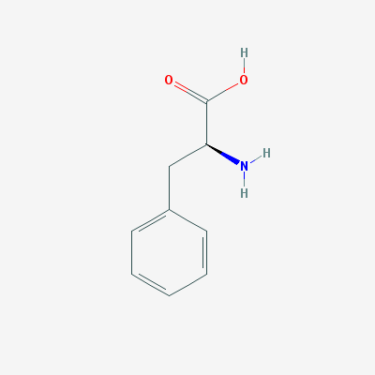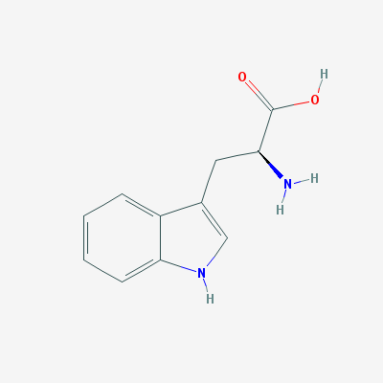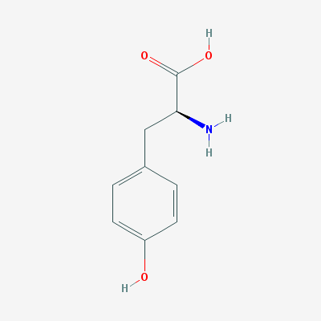

Figure 3. Molecular structures of (from left to right) tyrosine, tryptophan and phenylalanine

### Uses of fluorescence for the detection of bacteria

The presence of these proteinaceous substances has been suggested as a proxy to the presence of bacteria. Previous studies have shown that bacteria have spectral fingerprints within the proteinaceous substance region of fluorescence (roughly 200-400 nm excitation and emission) (Determann et al., 1998; Elliott et al., 2006). Furthermore, different studies have shown an ability to differentiate between different bacterial species, at a high concentration, in colonies (Belal et al., 2011) and in enriched blood samples (Walsh et al., 2013) using this method (at various ranges of excitation and emission wavelengths).

This has led to development of a method to detect bacteria and to quantify their presence in various types of water and specifically in drinking water. The full fluorescence map of *E. coli* suspended in distilled water is shown in Fig. 4 where emission intensity was measured in range of excitation and emission wavelengths. By measuring the emission of light at multiple pairs of excitation/emission wavelengths this data can provide a clear picture of the different organic elements in the sample (Figure 4). However, for measuring proteinaceous-like fluorescence in water, very often emission at a certain wavelength, after illuminating by monochromatic light at another specific wavelength, is used. For example, in order to measure tryptophan fluorescence Tedetti et al (Tedetti et al., 2013) used excitation at 280 nm and measured emission at 340 nm.

Figure 4. EEM of E. coli suspended in distilled water at a concentration of 105 CFU/ml. The intensity has been cutoff at 50 fluorescence units to enhance visibility.

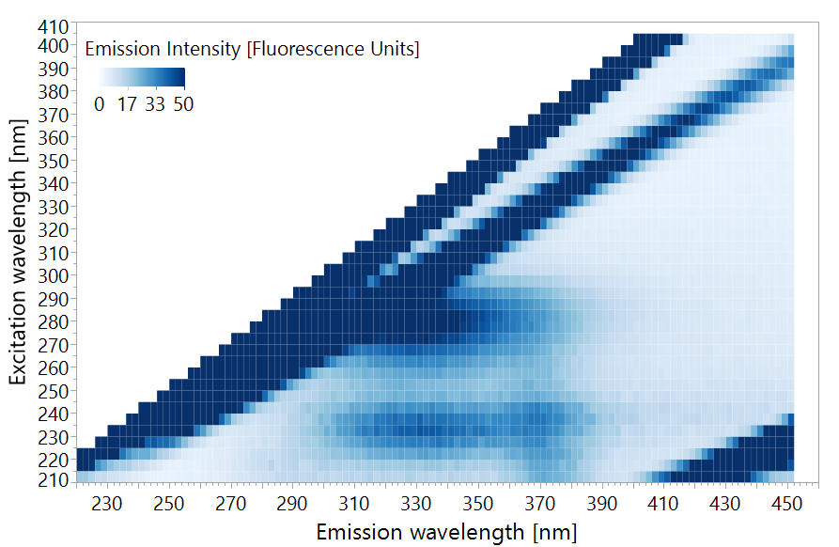

Sorensen et al, in 2015 (Sorensen et al., 2015), suggested the application of simple single-wavelength measurements of tryptophan fluorescence for the detection of microbial contamination of water. They used a portable fluorometer with excitation at 280 nm which measures emission at 360 nm on water taken from boreholes and shallow wells in Zambia. This study has shown the ability of this fairly simple instrument to detect an *E. coli* contamination of >1 CFU/100ml of water. The emission intensity measured was found equivalent to a solution containing ~3.5 ppb of tryptophan. A follow up study, by Baker et al (Baker et al., 2015) used a similar instrument to detect *E. coli* contaminations in low quality catchment water in South African rural areas. This experiment managed to accurately detect *E. coli* contamination at a concentration of >100 CFU/100ml with a tryptophan equivalence of 3 ppb (reflecting the emission associated with the whole microbial and non-microbial background at this excitation/emission wavelength pair). Further studies by Sorensen et al. show similar results, displaying an ability to detect low levels of *E. coli* contamination in low quality drinking water in India, Malawi and Zambia, with the tryptophan equivalence ranging between 1.5-3.5 ppb of tryptophan (Cumberland et al., 2012; Sorensen et al., 2018a). These studies suggest that the application of single-wavelength fluorescence spectroscopy, at the tryptophan peak of excitation-emission 280nm-360nm (+-10nm) can be used for the detection of bacteria in low quality water. It is important however to note that water with >1 CFU/100ml of *E. coli* is considered very low quality in most western countries. *E. coli* is only used as an indicator of other microorganisms, and the measured fluorescence does not represent only *E. coli* but is contributed also at least by other microorganisms. In this low quality water, *E. coli* is indeed indicative and proportional to the whole number of bacteria in water sample and therefore, fluorescence reflecting all the bacteria became correlated with E. coli. But *E. coli* may not correlate with the whole number of bacteria (especially in less severe contaminations) and then, fluorescence will not represent *E. coli*. The Israeli, European Union and United State regulations all prohibit consumption of water with this level of contamination, and the phenomena is relatively rare (Allen et al., 2004).

A similar study was performed in the UK, where the water quality is high, and used a lab-constructed fluorometer with a LED excitation light source at 280 nm and an ability to measure emission at 350 nm. In this study, measurements of both fluorescence and standard microbial indicators such as *E. coli* and heterotrophic plate counts (HPC) were carried out throughout the supply chain (at the source, in checkpoint in the pipeline and at home taps). Good correlation was found between the microbial indicators and the fluorescence intensity at the tryptophan peak (Sorensen et al., 2018b). These findings imply that measuring emission at a single excitation/emission wavelength pair may be sufficiently sensitive to monitor indicative microorganisms in high quality water or their presence does not correlate with the whole microbial background of water sample that contributes to fluorescence emission.

In 2018, Heibati et al investigated a multispectral approach to link fluorescence emission and presence of bacteria in drinking water in Sweden. While in earlier studes (full reference: Sorensen, Baker and Bridgman ), emission associated with tryptophan was studied at 360 nm upon exciting at 280 nm, Heibati et al (2018) used the EEM data covering the 220-600 nm excitation wavelength range and the 240-800 nm emission wavelength range. The EEMs were analyzed by multivariate statistical methods, including Partial Least Squares (PLS) and Parallel Factor Analysis (PARAFAC). Throughout the study's measuring period, the water samples did not show severe microbial contamination, and no *E. coli* or coliforms were detected. The only applicable microbial indicator was HPC, and only weak correlations were observed between the EEM data and HPC bacterial abundances. This may serve as an indication that at very low concentrations (<150 CFU/ml of heterotrophic bacteria) it is difficult to detect bacteria using the fluorescence measurement approach (Heibati et al., 2017).

These earlier studies demonstrated possibilities and some limitations of using fluorescence spectroscopy for detection of bacteria in water. To recall, this method, similarly to Raman spectroscopy, is relatively simple and cheap, requiring almost no sample preparation. It appears though, that fluorescence emission measurements at a single excitation/emission wavelength pair may not be sensitive enough to enable detection of low levels of bacteria, as required in most developed countries and in Israel. For this purpose, the multispectral EEM analysis approach could be more appropriate. When properly calibrated, it could be adopted in the water and food industry.

Add something about lab model systems

MB: Does Heibati consider in their work examination of a diluted lab series of the same bacteria? I mean not multiple natural samples for which CFU was independently determined but a lab series undergoing dilution? If not, the lack of correlations or the presence of correlations may easily reflect not the issue of sensitivity but the point that the whole fluorescing tryptophan background and the CFU counts do not correlate since CFU does not count all the bacteria and may not be proportional to their concentrations until samples are not diluted from a stock. The issue of sensitivity may be checked by the only way: when you take the known number of bacteria, dilute it and do your PLS analysis of very diluted solutions. In this case you may know for sure that fluorescence must be related to the microbial concentrations and you may learn where is the threshold? If they did it, they addressed one major question you are trying to discover, and got a weak result. (which might need to be discussed). If they did not do that, that is exactly the proper lab-based systematic novelty: checking of diluted solutions at low bacterial level and demonstrating the amplifying role of PLS analysis.

## Multivariate data analysis

Because of the complex nature of EEMs and Raman spectra, they are always analysed using multivariate statistics. Partial Least Squares (PLS) regression or PLS discriminant analysis performs well when the number of predictor variables is high and some variables correlate with each other (Heibati et al., 2017; Schmilovitch et al., 2005). Since it is a case when examining EEMs or Raman spectra comprised of signals (X­n) measured at hundreds of wavelengths, PLS was a suitable method for predicting bacterial concentration using spectral indicators. PLS algorithms find the correlations between these different variables (Xn), and then correlate those to the dependant variable (Y) – microbial concentration measures. Using an iterative process, this enables optimization of the importance or weight given to each variable and a prediction formula can be calculated (Equation 1) (Geladi and Kowalski, 1986).

Y = Predicted Bacterial concentration

*i* = the wavelength vector index (all wavelengths analysed)

ai= coefficient at wavelength *i*

X = light intensity at wavelength *i*

e = the calculated error

$$Y=\sum{a_{i}*X_{i}}+e$$

Equation 1 - PLS prediction formula

Prediction models might have a bias called overfitting, where your model is only relevant to your dataset, but performs poorly when tested on new data (Leinweber 2007). In order to overcome this, the data is split into calibration and validation sets. The model is first trained on the calibration or training set, and is then tested for accuracy and validity on the validation set. This approach is called cross validation and enables calibration of robust prediction models (Geladi and Kowalski, 1986; Gholizadeh et al., 2015).

The need for a fast, accurate method to enumerate bacteria in water is of high priority for public health (Collier et al., 2012). To serve this goal, spectroscopy-based methods have been suggested in the literature (refs), however, it is not yet clear how sensitive are they, what are their thresholds regarding minimal detectable bacterial concentrations, and how they perform in variable real-life scenarios in which variety of microorganisms is present and only a small and variable part of microorganisms could be grown by microbiology tools whereas all the microorganisms could provide their spectral fingerprints. Towards these scientific questions, this study examined two spectroscopy methods: low resolution Raman spectroscopy and fluorescence spectroscopy.

# Research objectives

The specific aims of this study are:

1. Test the detection thresholds of low resolution Raman spectroscopy combined with PLS for detecting bacteria in water
2. Test the detection thresholds of fluorescence spectroscopy for detecting bacteria in water and compare use of a single pair of excitation/emission wavelengths with analysis of the fluorescence spectra and the full EEM enhanced with PLS.
3. Compare the abilities of low resolution Raman and fluorescence spectroscopies and outline recommendations for further studies
4. Assess the ability of spectroscopy for detecting bacteria in real drinking water samples
5. Evaluate the ability of both low resolution Raman and fluorescence spectroscopy at differentiation between different species of model bacteria

# Materials and methods

## Materials and chemicals used

The materials used in this study are listed in Table 1.

Table 1. Material used in the study

|  |  |  |
| --- | --- | --- |
| **Materials and chemicals** | **Manufacturer** | **Origin (City, Country)** |
| Ethanol | Gadot | Netanya, Israel |
| HPLC-grade Water | Biolab | Jerusalem, Israel |
| HPLC-grade Water | Merck | Darmstadt, Germany |
| Agar | Difco | Sparks, USA |
| LB Broth | Difco | Sparks, USA |
| Glycerol | Biolab | Jerusalem, Israel |
| L-tryptophan | Sigma-Aldrich | St. Louis, USA |
| Delicate Task Wipers | Kimberly-Clark | Irving, USA |
| 0.45 µm Durapore Filters | Millex (Merck) | Darmstadt, Germany |

## Bacterial Strains

The following bacterial strains were used in this study: *Escherichia coli* DH5α, *Bacillus subtilis* 3610 and *Pseudomonas aeruginosa* PA14*,* all strains were taken from the lab stocks at the Volcani Center. These bacterial species were chosen because a) they represent the gram positive and gram negative groups, expected to have a different chemical composition (Jean and Simorre, 2018) and b) *P. aeruginosa* is a very common environmental pathogen which may be acquired from drinking water (Costa et al., 2015).

Bacteria were transferred from pure cultures stored at -20 0C (with 20% glycerol solution) and were grown on LB agar medium (Difco, Sparks, MD, USA) by incubating at 37°C overnight. Several well isolated colonies were harvested, suspended in a 10 or 15 ml of LB broth (Difco, Sparks, MD, USA) and incubated at 37°C with shaking overnight to prepare a starter culture. The stocks were later used in the sample preparation procedure in different ways for different experiments.

## Optical density to bacterial concentration calibration

In order to associate optical density with microbial concentration, liquid bacterial cultures were diluted to optical density (OD) of 1 using a benchtop photometer (Biochrom, Cambridge, UK) at 590 nm. The cultures were then serially diluted between 1:10 and 1:1010 and 100µL were plated on agar plates and incubated overnight in 37°C. Each dilution was plated 3 times for replicates, and 3 plates were incubated without inoculation as controls. After incubation, colonies were counted on the plates and the bacterial concentration of a 1 OD liquid culture was calculated to be ~108 CFUs/ml in *E. coli* and *B. subtilis* and ~109 CFUs/ml in *P. aeruginosa*.

## Preparation of L- tryptophan solution

A 107 ppb stock solution was prepared by dissolving 1 g of L-tryptophan powder (CAS number 73-22-3, Sigma-Aldrich, St. Louis, MO, USA) into 100 ml of non-fluorescence water (Merck, Darmstadt, Germany) at 80±10°C using an electric stirrer and hot-plate (Freed Electric, Haifa, Israel). The tryptophan stock solution was serially diluted to prepare a series of concentrations:1, 1, 2, 3, 5 and 10 ppb.

## Groundwater samples

3.5.1. Groundwater sampling

Groundwater samples were obtained from 6 drinking water wells in Israel between July 2017 and June 2018, prior to and after standard chlorination treatment (by what? gaseous chlorine?). The list of the groundwater wells, the frequency of sampling and the number of the samples collected are listed in Table 2. Water was collected in cleaned dark glass bottles and transported cooled (to which temperature?) to the ARO laboratory where it was stored in 4°C until analyzed.

Table 2. Groundwater sampling: wells, frequency of sampling and the number of samples collected

|  |  |  |
| --- | --- | --- |
| Groundwater well (code) | Sampling Frequency | Number of the collected samples (prior chlorination) |
| Alonei Ha’Bashan 5 (AAI05) | Monthly | 11 |
| Alonei Ha’Bashan 8 (AAI08) | Monthly | 10 |
| Kidmat Tzvi 1 (KDZ) | Intermittently between October 2017 and June 2018  22/10 26/12 15/01 20/03 23/04 23/05 18/06 | 7 |
| Shimron 7 (SH7) | Monthly | 11 |
| Einan 3 (QP003) | Summer (July-December 2017, March-June 2018): 2 per month  Winter (January-February 2018): 2 per week | 26 |
| Einan 6 (QP006) | Summer (July-December 2017, March-June 2018): 2 per month  Winter (January-February 2018): 2 per week | 34 |
| Total samples |  | 99 |

## 3.5.2 Testing sampled ground water according to standard methods in a certified lab

Independently to the spectroscopic analysis performed in the ARO (The Volcani Center), the sampled water was characterized in the certified service lab (Health ministry??? Give more detail? The city? Tel Aviv?) for coliforms, fecal coliforms, fecal streptococci, heterotrophic bacterial counts and turbidity (2016; Eaton et al., 2005). In chlorinated samples chlorine concentrations were also measured. Results were sent online

## Low resolution Raman spectroscopy measurements

## Sample preparation for scanning with Raman spectrometer

Prior to scanning with Raman instrument, 15 ml of bacteria culture were grown overnight in optimal conditions as elaborated in section XXX. The bacterial culture was centrifuged for 10 minutes at 4991 g (Heraeus Primo R, Thermo Scientific, Waltham, MA, USA). The supernatant was thrown away and the bacterial pellet re-suspended in 15 ml of distilled HPLC-grade water (Biolab, Jerusalem, Israel). This washing stage was repeated 3 times, and the final pellet was re-suspended in distilled HPLC-grade water to the volume necessary to reach optical density of 1. The sample was later serially diluted for each experiment. The samples were kept at room temperature during 1-3 hours and then spectra were obtained. Different sample preparations were used in some of the experiments as described in section ‎3.5.1 .

In order to enhance the bacterial Raman signal, the additional preparation had been made which included (1) boiling diluted bacterial suspensions for 15 min in 100°C in hot plate (Freed Electric, Haifa, Israel), (2) cooling bacteria in ice for an hour (Premasiri et al., 2017).

## Raman Instrumentation and scanning procedure

A 785 nm excitation laser was used (Ocean Optics laser module I0785MM0350MS, Ocean Optics, Largo, USA), coupled with a spectrometer (Ocean Optics QE65 Pro, Ocean Optics, Largo, USA) covering a wavenumber range 160.7-4142.2 cm-1 (or the 766 – 1100 nm wavelength range). Readings were done using a stainless-steel fiber optic probe (RamanProbe II 785/12-5, InPhotonics, Norwood, USA) attached to both laser and spectrometer. All data was collected using the OceanView software (version 1.52, Ocean Optics, Largo, USA) and exported as .CSV files for further analysis (Figure 5).

Unless otherwise stated, scans were done at 350 mW for 10 seconds, with 3 immediate scans averaged (for a total of 30 seconds exposure time). Prior to scanning, the height of the probe was adjusted to the best resolution of the peaks of 100% ethanol. “Dark” scans were measured with the laser off and auto-subtracted from the data to remove machine noise. After obtaining “dark” scans and adjusting probe height, the scanning procedure involved cleaning the loading aluminum cup (Figure 5) with 100% ethanol and delicate task wipers (Kimberly-Clark, Irving, USA) and loading 150µL of aqueous bacterial suspensions onto the cup. The aluminum cup was then placed under the probe and brought to correct height with all light sealed out. At this stage the laser would be turned on and the scan will commence. After each scan the cup was cleaned and reloaded. Each sample was scanned 3-5 times (depending on the experiment).

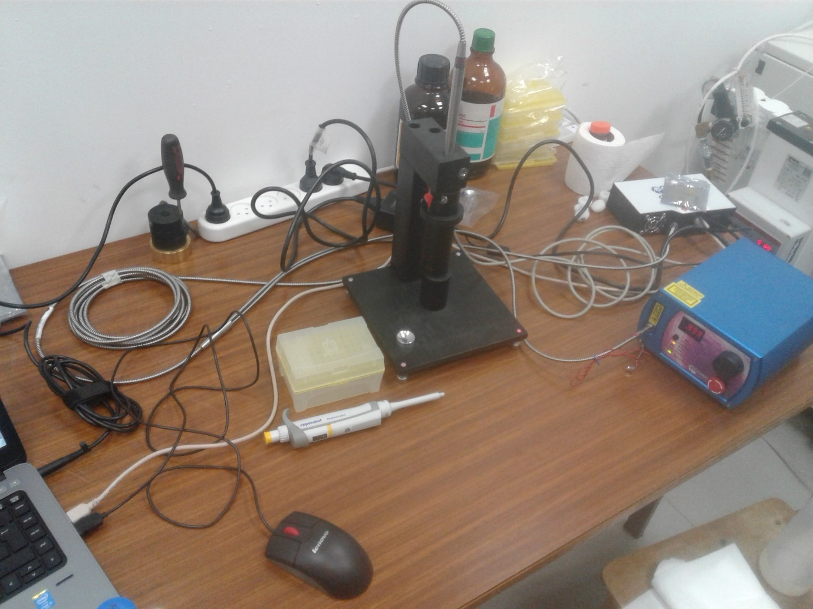

1

3

2

4

5

Figure 5. The Raman setup, including (1) excitation laser, (2) Probe, (3) spectrometer, (4) probe holder and (5) aluminum cup.

## Survival test under sample preparation, transfer and radiation

In order to verify that irradiation by the 785 nm laser does not compromise cell viability, a sample of water with 108 CFU/ml *E. coli* and a sample of clean water were placed in an aluminum cup and irradiated by laser for 30 seconds. After that, the samples were variously diluted (1:103, 104, 105, 106 ) and plated on agar plates. The plates were incubated for 24 hours in 37°C and colonies were counted.

## Fluorescence spectroscopy measurements

Fluorescence spectra of water samples were measured with an RF-5301PC spectrofluorometer (Shimadzu, Kyoto, Japan) equipped with 150-W Xenon lamp (Ushio Inc., Tokyo, Japan) as described by Borisover et al. (2009, 2011). Prior to scanning the water sample was brought to room temperature by leaving the bottles in room temp for approx. 3 hours. The cuvette used was the standard quartz cell (Hellma, Müllheim, Germany) having a path length of 10 mm and chamber volume of 3,500 μL. Scanning was done at 22±2°C. Fluorescence emission spectra between 220 and 450 nm were collected at 2-nm increments, with excitation wavelengths ranging from 210 to 400 nm at 5-nm increments. Scanning rate per map was about 2.5 minutes and the excitation and emission optical slits were set to 10 nm. Instrument stability was controlled by measuring the intensity of the Raman peak of water at excitation wavelength at 275 nm and emission wavelength at 305nm. Cuvettes were washed 3 times with HPLC-grade water (Merck, Darmstadt, Germany) before the beginning of scanning, and washed by 6 ml of sample water between each scan. 3 ml of sample water were loaded for scanning. The cuvette was aligned to the same side for scanning. Water samples were scanned as is and after lab filtration using a 0.45 µm syringe filter (Durapore©, Millex (Merck), Darmstadt, Germany). Prior to filtration, 15 ml of sample water were used to wash the filter. Each sample was scanned with spectrofluorometer twice independently (I e a separate 3ml.

## UV absorbance scanning

Optical density at 210 nm was checked in every drinking water sample before fluorescence measurement using a Genesys UV-Visible spectrophotometer (Thermo Scientific; Cat. 335906-02; Madison WI 53711; USA) to ensure it is sufficiently low to prevent an inner filter effect.

## Statistical analysis

## Mathematical sample preparation – preprocessing

Data preparation for the analysis needs preprocessing. We first optimized our protocol to find the best preprocessing procedure by the following procedures:

1. Signals recorded were normalized. Normalization, i.e., a ratio of signal to a set point, minimizes the interferences which may originate from variation of ambient temperature, lamp intensity and other factors supposed to affect similarly the signal and the reference point. In the Raman experiments this was done by dividing all intensities in the spectra by the maximum point in the spectra, thus achieving a range of 0-1 for all data points, while retaining the relations between different peaks. In the fluorescence measurements this was done by dividing the signal to the Raman signal of water. Normalization was done using Excel software (Excel 2016, Microsoft, Redmond, WA, USA).
2. Centering and scaling processes were done automatically using the JMP software (JMP®, Version 13 Pro (SAS Institute Inc., Cary, US).) prior to running the PLS analysis. These procedures are commonly used in the PLS analysis and reduce noise to enable better fitting of the model (Geladi and Kowalski 1986).
3. Signal weighing was performed by using the 1/signal and log10(1/signal values. This procedure serves to increase weak signals and uncover more information about a sample (Mizrah 2007). Weighed signals were calculated using Excel software.
4. The 1st derivative of spectra was obtained in order to amplify the trends in the data. It was done by calculating signalEm(n)-signalEm(n-1). The first data point in each spectrum was assigned "0", as for this point signalem(n-1) does not exist. The 1st derivative of spectra was calculated using Excel software.

In order to analyze only fluorescence data, all data-points in the EEMs where the excitation wavelength is longer than the emission wavelength were removed.

The preprocessing method with the highest R2 was chosen for further analysis. In case of equal R2 values, the method with the lowest RMSE was chosen

## Partial Least Squares treatment of the collected spectral experimental data

All statistical analysis was done using JMP®, Version 13 Pro (SAS Institute Inc., Cary, US). In this work Partial Least Squares (PLS) NIPALS algorithm ("Nonlinear Iterative Partial Least Squares") was used to both quantify and classify bacteria. Classification was done using a Partial Least Squares Discriminant Analysis (PLS-DA) option. Each PLS model consists of several latent variables (LV) or factors. The number of latent variables represents the complexity of the model, a general rule of thumb is that LVs of a good model should be between 3-10 (Geladi and Kowalski, 1986). Variable importance (VI) is a measure of the importance of each variable in the model for the predictive ability. It is calculated by sum of the decrease in error when split by a variable (Wold 2001). For the analysis of EEMs, it was required to reduce the dimensionality of the data from 3-dimentional- to 2-dimentional-martrices, since PLS can only work with 2-dimentional data. For this purpose, each excitation-emission wavelength pair was given an index number and the EEM was transformed into a table of indices (excitation-emission wavelength pair) and emission intensities prior to modelling.

Further, square of regression coefficients (R2); a measure of model correlation with actual values and Root Mean Square Errors (RMSE); a measurement of the model's error rate in the units of measurement were calculated using JMP software. RMSE was calculated according to Equation 2 (Fearn, 2002).

Equation 2 - calculation of Root Mean Square of Error (RMSE)



Statistical significance were computed using JMP software. Statistical significance was analyzed by using the Student's t-test and Wilcoxon rank-sum test (also known as the Mann-Whitney test). In order to test whether the variance of two groups is equal, Levene's test was used. Throughout the study, statistical significance was required to be p<0.01. Cohen's kappa coefficient, which is a measure of the agreement between 2 methods for measurement, was also calculated using JMP.

# Results and discussion

## Use of Raman Spectroscopy for quantification of microorganisms and species differentiation

Initially, aqueous suspensions of *E. coli, B. subtilis* and water were scanned using a low resolution Raman spectrometer, with laser excitation of 785 nm, in an attempt to identify indicative peaks for bacteria. The data did not show any significant peaks or areas of major deviation between the bacteria suspensions and the water samples, even at a concentration of 108 and 107 CFU/ml (Figure 6). This is because the Raman signal of bacteria is very weak and complex, and even at its high concentrations the chance of a Raman scatter occurring at a frequency which can be clearly visible using a low-resolution instrument is low (Jarvis et al., 2006; Schmilovitch et al., 2005).

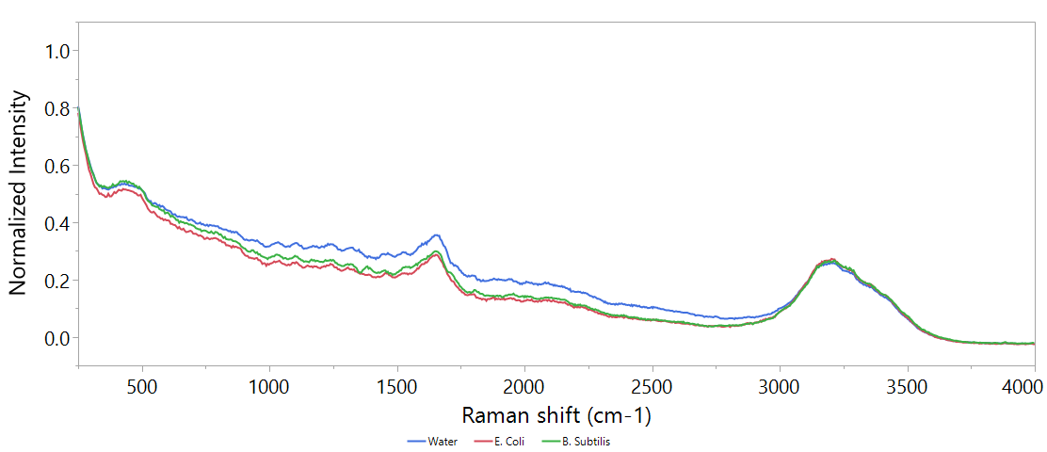

Figure 6. An example of the Raman spectra of clean double-distilled water, E. coli at a concentration of 108 and B. subtilis at a concentration of 107 CFU/ml. Excitation is by 785 nm laser, for 5 seconds, 3 scans were averaged.

Different attempts have been made to improve the spectrum, by increasing time, cooling the samples to 4°C or boiling the samples to lyse the cells. None of these treatments showed significant improvements (data in supplementary). Since no clear difference could be found visually, a PLS model was designed to try and expose underlying information.

### PLS model

We optimized the PLS model based on the *B. subtilis* dataset (n=184), since a slightly better resolved spectrum could be recognized visually for this this microorganism.,

In order to build a set protocol, different preprocessing approaches were tested and their statistical characteristics are detailed in Table 3. These include latent variables (LVs), RMSE and R2. In all methods, the same attribution of calibration-validation sets was used, with 60% of samples used for calibration and 40% for validation.

Table 3. Comparison of different preprocessing approaches: RMSE and R2 values are calculated on validation set, n=74. LVs = Latent variables. The best method is the one that shows the highest R2 with the lowest possible RMSE, and is in **bold**.

|  |  |  |  |  |  |
| --- | --- | --- | --- | --- | --- |
| # | Preprocessing 1 | Preprocessing 2 | LVs | RMSE | R2 |
| 1 | **None** | **None** | **7** | **1.04** | **0.56** |
| 2 | None | Centering | 7 | 1.14 | 0.58 |
| 3 | None | Scaling | 3 | 0.4 | 0.08 |
| 4 | None | Centering + Scaling | 5 | 1.35 | 0.51 |
| 5 | Normalized to Max | None | 7 | 1.07 | 0.56 |
| 6 | Normalized to Max | Centering | 6 | 1.07 | 0.58 |
| 7 | Normalized to Max | Scaling | 11 | 1.43 | 0.29 |
| 8 | Normalized to Max | Centering + Scaling | 6 | 1.46 | 0.4 |
| 9 | Normalized + 1/signal | None | 6 | 0.78 | 0.06 |
| 10 | Normalized + 1/signal | Centering | 8 | 1.03 | 0.07 |
| 11 | Normalized + 1/signal | Scaling | 8 | 1.42 | 0.22 |
| 12 | Normalized + 1/signal | Centering + Scaling | 6 | 1.41 | 0.41 |
| 13 | Normalized + LOG10(1/signal) | None | 2 | 0.74 | 0.17 |
| 14 | Normalized + LOG10(1/signal) | Centering | 2 | 0.72 | 0.23 |
| 15 | Normalized + LOG10(1/signal) | Scaling | 3 | 0.75 | 0.23 |
| 16 | Normalized + LOG10(1/signal) | Centering + Scaling | 5 | 1.2 | 0.5 |
| 17 | Normalized + 1st derivative | None | 2 | 1.22 | 0.46 |
| 18 | Normalized + 1st derivative | Centering | 1 | 1.22 | 0.45 |
| 19 | Normalized + 1st derivative | Scaling | 2 | 1.14 | 0.37 |
| 20 | Normalized + 1st derivative | Centering + Scaling | 1 | 1.16 | 0.38 |

Since no preprocessing was found to best describe the data, following analysis was done without any preprocessing.

### Establishing detection thresholds

Constructing a PLS model for quantifying both *E. coli* and *B. subtilis* has shown significant difference between species detection thresholds. While *E. coli* could only be detected at 108 CFU/ml, *B. subtilis* prediction models enabled confident detection at 104 CFU/ml (Figure 7).

Figure 7. Top: regression of predicted bacterial concentration according to PLS model against real bacterial concentration of E. coli and B. subtilis. Bottom: box plot of the data as used for threshold analysis. Boxes illustrate median and interquartile range (IQR), whiskers indicate 25th and 75th percentile, outliers are shown. Asterixes signify diffrence from control (concentration of 0 CFU/ml) according to Student's t-test, p<0.01 .N of E. coli = 197, N of B. subtilis = 74. Only validation set is shown.

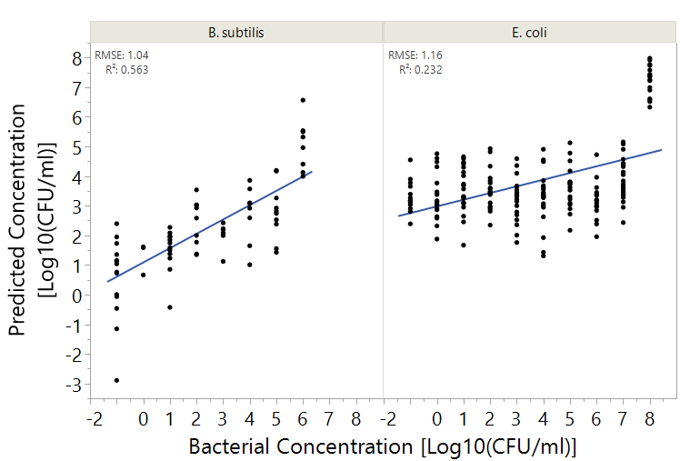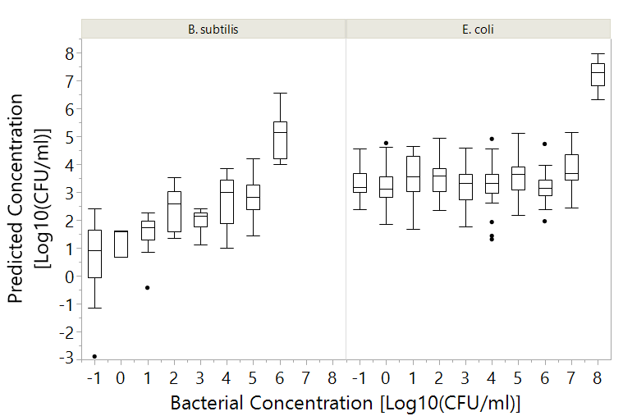

*

*

*

*

Since detectable E coli concentrations are very high, the analytical performance of this method for this species is generally not sufficient. However, in the case of *B. subtilis,* a significant improvement of detection capability is expected when using low resolution Raman spectroscopy as compared with use of absorbance at 590 nm. However, the whole result does not seem promising for the rapid and accurate detection of bacteria in water

### Differentiation between species

In order to explain the differences between the prediction abilities of *E. coli* and *B. subtilis*, variable importance (VI) was calculated and plotted (Figure 8). It appears that the different bacteria have widely different spectral fingerprints. Furthermore, the major spectral fingerprint of *B. subtilis* is in the functional group region between 3,000-4,000 cm-1 (Figure 8) and shows a sharp pattern. This region signifies that the signal was likely from biological molecules such as sugars and lipid functional groups (Premasiri et al., 2005; Zeiri et al., 2004; Zeiri and Efrima, 2010). It is difficult however to assign a specific structure to the fingerprint since ???. The fingerprint of *E. coli* appears more smeared throughout the spectrum, which may indicate an absorbance signal, since it coincides with the Raman spectra of water (George, 2001). This is supported by the fact that below the 108 CFU/ml, no clear signal was observed and the PLS model could not find any variation, much like in the use of standard absorbance photometers below the 108 CFU/ml threshold no absorbance is observed. It does appear, however, that *E. coli* has some signal that is within the functional group region, and other smaller peaks between 2,500-3,000 and 1,300 cm-1. The fingerprints of both bacteria resembles each other in the fingerprint region 500-1,000 cm-1 which may be a fingerprint of bacteria that differentiates them from water.

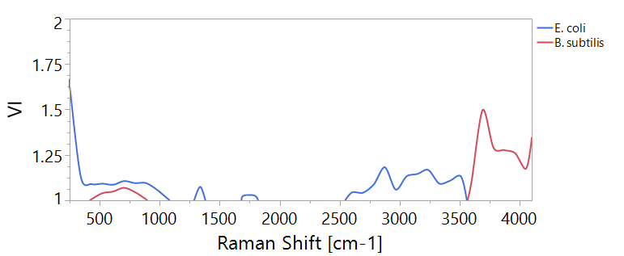

Figure 8. Variable importance (VI) plot of PLS models for quantification of bacteira according to Raman spectra. The plots show only values >1. A is the fingerprint region, B is the functional group region.

B

A

It is difficult to explain why *E. coli* does not show a spectral fingerprint while *B. subtilis* does. Differences in the cell wall structures between two types of bacteria, i.e., gram positive (*B. subtilis*) and gram negative (*E. coli*), may cause a different scatter effect. Further research might be needed to explain the molecular nature of the differences in recognizing different bacteria by means of low resolution Raman spectroscopy.

These findings suggest the possibility of differentiation between different bacterial species using Raman spectroscopy. In order to examine the ability of Raman spectroscopy to identify the bacteria in water, control experiments were carried out with the samples divided into 3 categories:

1. *E. coli* at 108 CFU/ml (n=42)
2. *B. subtilis* at 106 CFU/ml (n=51)
3. Clean water samples (n=67)

Then, a PLS-DA (Discriminant Analysis) model was calculated, in an attempt to classify these samples correctly, with the same training-validation ratio of 60% calibration and 40% validation. Table 4 illustrates the model's ability to accurately differentiate between two different bacteria and water using a confusion matrix. This allows visualization of the performance of the model, where each row of the matrix represents the instances in an actual class while each column represents the instances in the predicted class. Wherever the actual and prediction coincide is highlighted. As can be seen in Table 4 the model accurately differentiates between *E. coli* and *B. subtilis*, and also detects their presence in water. This model has almost prefect agreement according to its Cohen's kappa coefficient of 0.89 (Landis and Koch, 1977), indicating the significant predictive abilities of the low resolution Raman spectroscopy data when modelled.

Table 4. Confusion matrix of classification of bacteria by PLS-DA, based on Raman spectra, at concentrations 108 and 106 CFU/ml for E. coli and B. subtilis respectively. Only validation set is displayed.

|  |  |  |  |  |  |
| --- | --- | --- | --- | --- | --- |
|  | Prediction  κ=0.89 | | | | |
| Actual |  | *B. subtilis* | *E. coli* | Water | Total |
| *B. subtilis* | 17 | 1 | 1 | 19 |
| *E. coli* | 0 | 18 | 0 | 18 |
| Water | 3 | 0 | 27 | 30 |
| Total | 20 | 19 | 28 | 67 |

Taken all together, these results indicate unfortunately a poor ability to detect bacteria in water using low resolution Raman spectroscopy. This lack of success was surprising since several earlier studies have already demonstrated a potential of this spectroscopy for detecting bacteria (Mizrach et al., 2007; Schmilovitch et al., 2005; Stöckel et al., 2015). One of the possible explanations for this current discrepancy is that the current instrument may not be appropriate for this job, and a more sensitive, yet still cheap, instrument may yield better results. It has been hypothesized that suspending the bacteria in distilled water would weaken? The intensity of their Raman spectra, due to osmotic-stress-related lysis, or that the laser used might damage the cells thus reducing the signal. However, a simple viability test has shown that the cell viability has not been compromised due to suspension in distilled water and irradiation. Moreover, neither the use of lower laser energy nor suspending the cells in a saline solution instead of water improved Raman signal (data not shown).

## Use of fluorescence spectroscopy for quantification of microorganisms and species differentiation

### Fluorescence emission of microorganisms examined at a single excitation/emission wavelength pair

In fluorescence spectroscopy, one approach in sample analysis is the "peak picking" or measuring emission intensity at a certain wavelength, after excitation by an another wavelength, lesser by magnitude. This method has been applied in many studies for the detection of microbial contamination of water, based on fluorescence of proteinaceous substances in the tryptophan-like-fluorescence (TLF) area (at the of 275±5 nm excitation and 360±10 nm emission (Baker et al., 2015; Bridgeman et al., 2015; Cumberland et al., 2012; Sorensen et al., 2018a; Sorensen et al., 2015; Sorensen et al., 2018b). In these studies, the minimal detectable microbial concentration was equivalent to the 1-3 ppb concentration of free tryptophan.

#### Calibration curve for tryptophan concentration

We used dilutions of L-tryptophan at concentrations of 0.1, 1, 2, 3, 5 and 10 ppb. Each dilution was scanned 3 times and 2 scanning sessions were conducted (meaning 6 scans per concentration). The maximum fluorescence peak of tryptophan was visually found to be at 362 nm after excitation of 275 nm.

Figure 10. Correlation between tryptophan concentration and fluorescence at 362 nm after at excitation of 275 nm. N=48 (51-3 excluded).. p<0.01 according to Student's t-test.

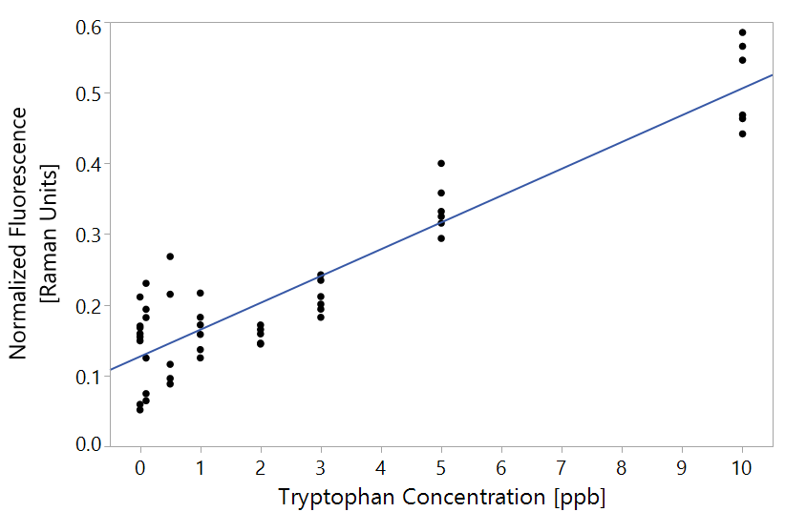





Equation 3. Claculation of tryptophan equivalence from normalized fluorescence

#### Quantification of individual lab-grown bacteria suspended in double distilled Non-fluorescent water

The tryptophan-like fluorescence (at excitation/emission of 275 and 362 nm respectively) of *E. coli, B. subtilis* and *P. aeruginosa* in high-purity non-fluorescent water was plotted against the concentration of microorganisms (in CFU/ml) in Figure 10. The log concentration given as "-1" is assigned to zero CFU/ml value. Figure 10 illustrates the detection thresholds of the emission measurements at single excitation/emission wavelength pair in detecting different bacterial species. All significance is tested using a Wilcoxon non-parametric test, since the variances are not equal according to Levene's test. The differences in fluorescence can only be observed when bacterial concentration reached 103-104 which is roughly 0.15 Raman units or the equivalent of ~ 3 ppb of tryptophan calculated using Equation 3 (Figure 10).

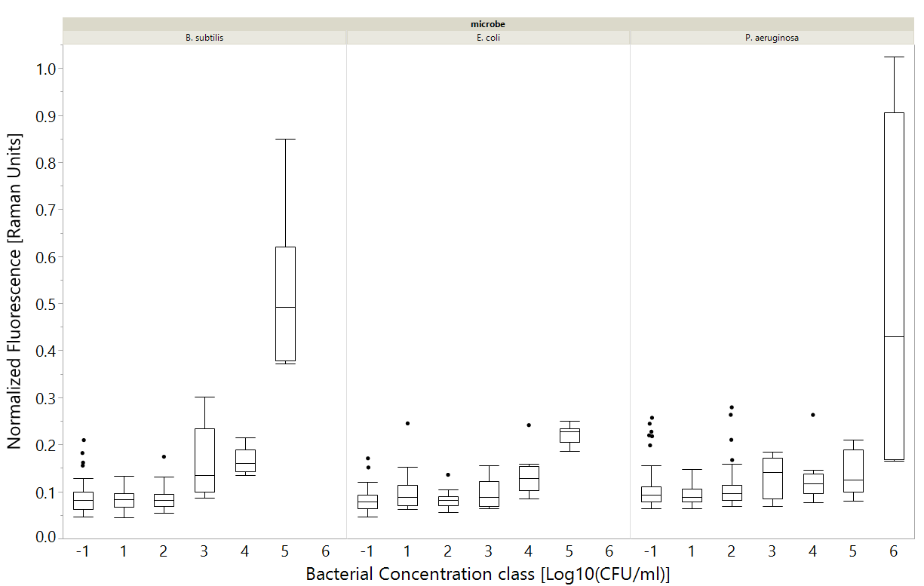

**\***

**\***

**\***

**\***

**\***

**\***

**\***

**\***

Figure 11 Fluorescence measurements at excitation-emission of 275-362 nm correlated with specific bacterial species. Bacterial concentration of (-1) means 0 CFU/ml. Astrixes mean significant differenct according to a Wilcoxon test, p<0.01. n indicated at the top. Bacterial concentration class means the all measurements were rounded to nearest class (ie 1,2,5 CFU/ml regarded as 1) for convenience. Box plots shows the middle quantiles in box, with whiskers for bottom and top values. The crosshairs in the whiskers signify the 90% mark.

This suggests that the studies using microbial detection at a single excitation/emission wavelength and claiming the detection limit equivalent to 1-3 ppb of tryptophan are capable of detecting bacteria at the ~105 CFU/ml level. This detection limit seems to be insufficient to the requirements of Israeli Ministry of Health regulations (2013), but it could have implications, e.g. in water, food, pharmaceutical and beverage industry for monitoring microbial contamination at a relatively early stage, and much earlier than most methods enable, using a quick, cheap fluorimeter.

#### Detection of heterotrophic bacteria in groundwater

Further, groundwater samples from 6 wells in Israel were examined in the period between July 2017 and June 2018 by means of fluorescence spectroscopy. Over the entire sampling period, only 1 sample contained >1,000 CFU/ml of heterotrophic bacteria (heterotrophic plate counts, HPCs). That sample was also the only one to contain *E. coli* >1 CFU/100ml*.* Therefore, the only available microbial indicator was HPCs. Fluorescence emission intensity is plotted against the HPCs of groundwater in Figure 12. The right panel includes outliers with >300 CFU/ml (marked as Xs). Figure 13 demonstrates that measuring fluorescence emission at a single excitation/emission wavelength was sufficient to differentiate between water samples of different concentrations (according to Wilcoxon ranked sum test, p<0.01).

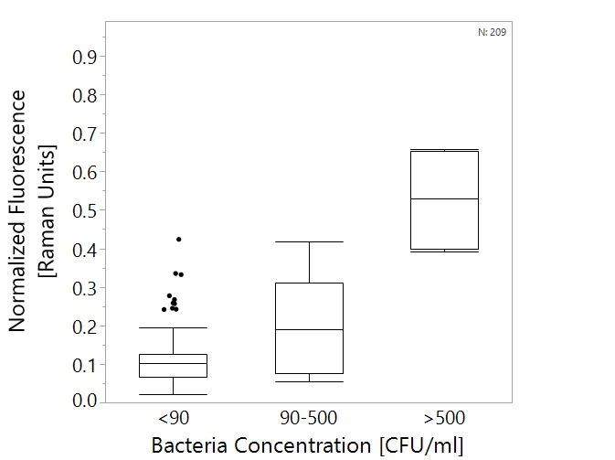

Figure 13. Box plots of tryptophan-like fluorescence measurements vs. heterotrophic bacteria counts in groundwater. All groups are significantly differenct from each other according to a Wilcoxon test, p<0.01. n=209. Boxes illustrate median and interquartile range (IQR), whiskers indicate 25th and 75th percentile, outliers are shown.

**\***

**\***

Figure 12. Correlation between Fluorescence measurements at excitation-emission of 275-362 nm and HPCs in groundwater samples. The right graph shows the entire data set (n=209) and the left one includes only the data with CFU<300. All regressions are statistically significant, with p-value < 0.0001 using a Student's t test.

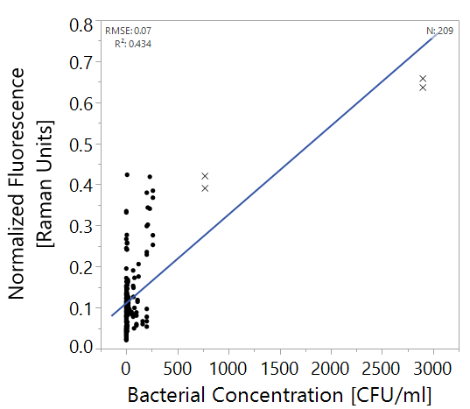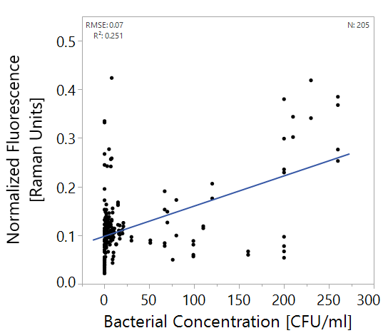

#### Case study – “Shimron”

The water sample from Shimron well obtained at 22/5/2018 was the only case of severe contamination of water. This sample was the only sample in the entire dataset with >1,000 CFU/ml, i.e., having 2,900 CFU/ml of heterotrophic bacteria, with 2 CFU/100ml of *E. coli* (an indicator of fecal contamination). The raw sample had very strong fluorescence (Figure 13) easily detected visually, however, chlorination at the treatment site (B) and/or lab filtration with 0.45 µm filter (BC,D) reduces significantly tryptophan-like fluorescence at the excitation range of 210-280, and emission at 320-380).

Figure 15. EEMs of Shimron 7 water sampled on 22/5/2018. (A) raw water, (B) chlorinated water, (C) filtered raw water, (D) filtered chlorinated water.

A

B

C

D

Fluorescence of all other groundwater samples was practically non-detectable visually (as exemplified in Figure 14). All samples showed strong optical signals along the Rayleigh scatter line (where the excitation wavelength equals to emission wavelength) and lesser one (but yet significant) along the Raman scatter line of water (marked in Figure 14) however, no distinct signals of proteinaceous (or any other fluorescence) could be easily detected.

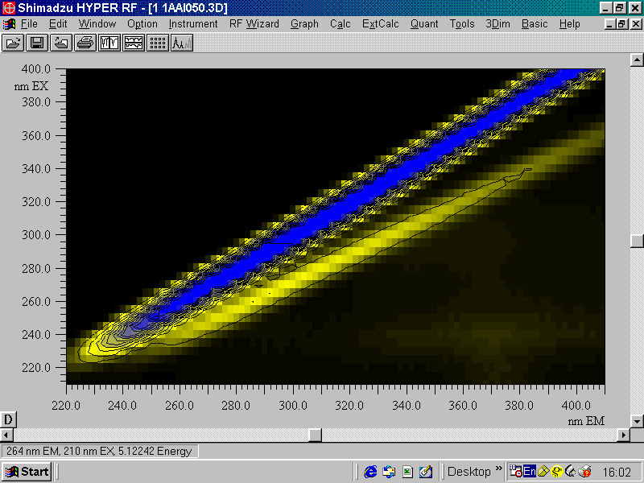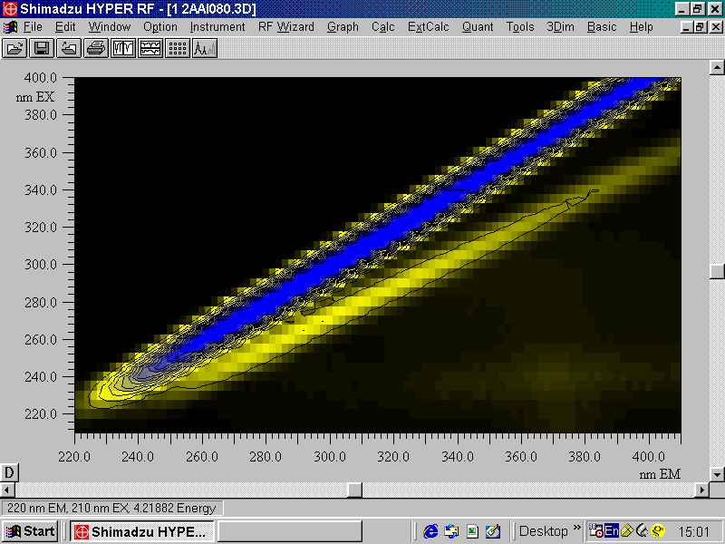

CFUs/ml = 16

CFUs/ml = 140

Figure 16. EEMs of groundwater samples with different concentrations of naturally present bacteria, indicated in white. The zone marked in blue is the Rayleigh scatter region, and the area surrounded by a red, dashed line is the Raman scatter region.

Examining the highly contaminated samples, it was clear that the emission was not limited to the TLF region but was actually spread over a large area of the EEM, including the entire proteinaceous region ( the 220-300 nm excitation wavelength range, the 300-380 nm emission wavelength range ,(Yang et al., 2015)), the edge of the humic substance region (excitation in the 210-300 nm range and the emission above 400 nm ,(Yang et al., 2015)) and also included a strong peak with excitation around 210 nm and emission at 370±10 nm emission, as described by Simelane (Simelane, 2013). This has led us to believe that examining the entire EEM could improve significantly the detection abilities. This was particularly relevant since samples with <500 CFU/ml showed very little overall fluorescence (Figure 14). Such weak signals could be properly analyzed using PLS multivariate analysis.

### Multispectral fluorescence spectroscopy and PLS analysis

Another common approach for analysis of fluorescence data uses entire excitation-emission matrices (EEMs) ((Borisover et al., 2009; Carstea et al., 2016; Heibati et al., 2017)). This enables taking into account the large emission regions previously mentioned. PLS regression enables the formulation of a model for predicting the concentration of bacteria in water, based on the entire EEM data.

First, a series of preprocessing approaches were tested on the *E. coli* data set (n= 137) (Table 6). In all methods, 60% of the samples were used to calibrate a model, and 40% of the samples served to validate it.

Table 6. Comparison of different preprocessing approaches: RMSE and R2 values are calculated on validation set, n=60. LVs = Latent variables. The best method is the one that shows the highest R2 with the lowest possible RMSE, and is in **bold**.

|  |  |  |  |  |  |
| --- | --- | --- | --- | --- | --- |
| # | Preprocessing 1 | Preprocessing 2 | LVs | RMSE | R2 |
| 1 | None | None | 12 | 0.96 | 0.62 |
| 2 | None | Centering | 11 | 0.97 | 0.60 |
| 3 | None | Scaling | 2 | 0.61 | 0.59 |
| 4 | None | Centering + scaling | 4 | 0.77 | 0.68 |
| 5 | Normalized | None | 10 | 1.12 | 0.54 |
| 6 | Normalized | Centering | 9 | 1.15 | 0.55 |
| 7 | Normalized | Scaling | 2 | 0.9 | 0.49 |
| 8 | Normalized | Centering + scaling | 8 | 0.98 | 0.65 |
| 9 | Normalized + 1/signal | None | 7 | 0.7 | 0.74 |
| 10 | Normalized + 1/signal | Centering | 7 | 0.78 | 0.72 |
| 11 | Normalized + 1/signal | Scaling | 13 | 0.74 | 0.78 |
| 12 | **Normalized + 1/signal** | **Centering + scaling** | **7** | **0.7** | **0.78** |
| 13 | Normalized + LOG10(1/signal) | None | 7 | 0.85 | 0.71 |
| 14 | Normalized + LOG10(1/signal) | Centering | 7 | 0.83 | 0.73 |
| 15 | Normalized + LOG10(1/signal) | Scaling | 8 | 0.79 | 0.72 |
| 16 | Normalized + LOG10(1/signal) | Centering + scaling | 8 | 0.73 | 0.77 |
| 17 | Normalized + 1st derivative | None | 1 | 0.13 | 0.1 |
| 18 | Normalized + 1st derivative | Centering | 5 | 0.96 | 0.45 |
| 19 | Normalized + 1st derivative | Scaling | 3 | 0.81 | 0.48 |
| 20 | Normalized + 1st derivative | Centering + scaling | 4 | 0.83 | 0.45 |

Since the combination of normalization, 1/signal centering and scaling was found to best describe the data, i.e., having the highest R2 value with the lowest RMSE, this protocol was used for the rest of the analysis.

#### Quantification of lab-grown *E. coli* suspended in double distilled Non-fluorescent water: a PLS-enhanced efficacy

The PLS algorithm was used to quantify *E. coli* in lab prepared suspensions both by using emission spectra obtained at a certain excitation wavelength and by analyzing the full EEM. The idea of introducing emission spectrum obtained at a single excitation wavelength into the consideration was that if it would be found successful and competitive with the full EEM analysis, operational and computational costs can be reduced. Both quantification methods were compared also with use of a single excitation/emission wavelength pair, as was described in detail in section XXX. Therefore, the detection thresholds and regression coefficients (R2) were compared for 3 possible detection methods:

1. Single wavelength method – the emission intensity at 362 nm upon excitation at 275 nm
2. Emission spectrum recorded in the 220-450 nm wavelength interval upon excitation at 275 nm.
3. The entire EEM obtained for excitation and emission wavelengths between 210-400 and 220-450 nm, respectively.

In order to measure predictive abilities for the Single excitation/emission wavelength pair, a calibration curve was plotted, linear regression was calculated and predictions were made based on the regression equation (Figure 17).

Detection threshold was defined as the lowest concentration level differing from <10 CFU/ml. Tukey-Kramer tests were used. (Table 7, Figure 18).

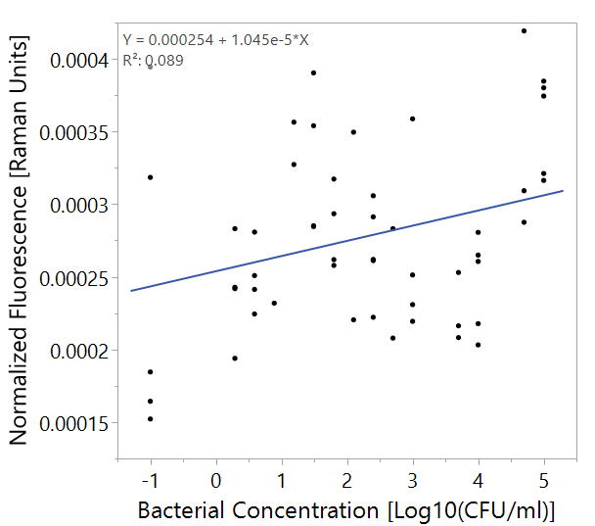

Figure 17. Linear regression of E. coli concentration and normalized fluorescence at excitation/emission pair 275/362. N=53.

Table 7 Comparison of fluorescence-based methods for the detection of bacteria. Analysis was performed for the validation sets of the E. coli dataset. Detection threshold defined as a difference between the indicated concentration and <10 CFU/ml is different significantly (p<0.01). n=53.

|  |  |  |  |
| --- | --- | --- | --- |
| Method | R2 | RMSE  [Log10 (CFU/ml)] | Detection Threshold  [CFU/ml] |
| Single excitation/emission wavelength pair [275/362] | 0.09 | 0.22 | 105 |
| PLS-analyzed emission spectrum obtained upon excitation at 275 nm | 0.59 | 1.14 | 103 |
| PLS-analysed full EEM | 0.73 | 1.02 | 10 |

Figure 18. Left: regression of bacterial concentration with different detection methods, Right: box plot of the data as used for threshold analysis. Boxes illustrate median and interquartile range (IQR), whiskers indicate 25th and 75th percentile, outliers are shown. N=53.

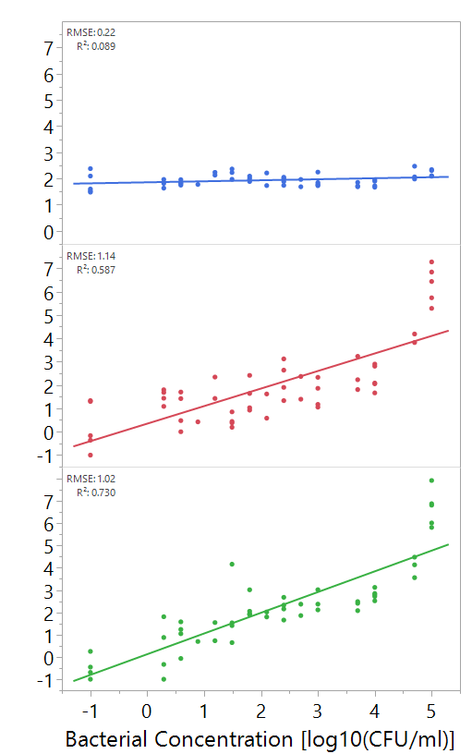

Predicted Bacterial Concentration [log10(CFU/ml)

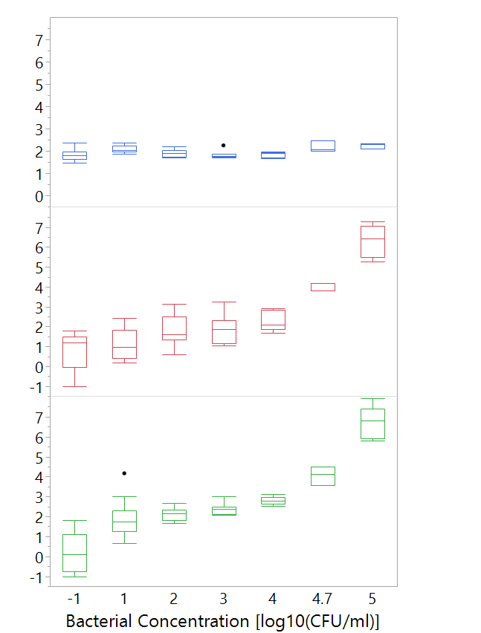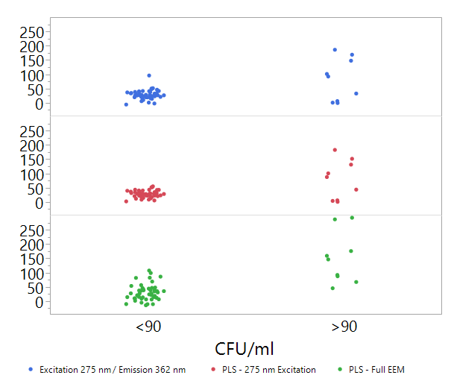

#### Detection of *E. coli, B. subtilis* and *P. aeruginosa* suspended in water using PLS-analyzed emission spectrum obtained upon excitation at 280 nm or full EEMs

At this stage, PLS models were created to try and predict bacterial concentrations of *E. coli, B. subtilis* and *P. aeruginosa* as representatives of common pathogens. These bacteria were selected as they represent both gram positive (*B. subtilis)* and gram negative (*E. coli and P. aeruginosa*) bacteria and because they have industrial and medical significance. Each strain was first modeled alone, and later all samples were modeled together.

Detection threshold defined as a difference between the indicated concentration and <10 CFU/ml is different significantly (p<0.01), using Wilcoxon ranked-sum test or Tukey-Kramer when available. Results are shown in Table 8.

Table 8. Detection of bacteria in water: comparison of fluorescence-based PLS-supported approaches. All R2 values are statistically significant at p<0.01?.

|  |  |  |  |  |  |
| --- | --- | --- | --- | --- | --- |
| **Bacteria** |  | E. coli  (N=53) | B. subtilis  (N=46) | P. aeruginosa  (N=86) | All bacteria together (N=185) |
| **Emission spectrum upon excitation at 275 nm** | **RMSE**  [Log10(CFU/ml)] | 1.14 | 0.74 | 0.9 | 0.83 |
| **R2** | 0.59 | 0.42 | 0.19 | 0.25 |
| **Detection threshold** (Wilcoxson)  [CFU/ml] | 5*104 | 105 | 105 | 104 |
| **Detection threshold** (Tukey-Kramer)  [CFU/ml] | 103 | --- | 106 | --- |
| **Full EEM** | **RMSE**  [Log10(CFU/ml)] | 0.76 | 1.01 | 1.04 | 1.06 |
| **R2** | 0.74 | 0.65 | 0.55 | 0.48 |
| **Detection threshold** (Wilcoxson)  [CFU/ml] | 10 | 104 | 10 | 100 |
| **Detection threshold** (Tukey-Kramer)  [CFU/ml] | 10 | 103 | 10 | 100 |

The detection thresholds of these species differed when using the entire EEM or only the single emission spectrum: the differences reached 1-5 orders of magnitude (Table 8). This indicates that the single emission spectrum does not capture the entire spectral fingerprint of the bacteria. This is possible because a large fraction of the proteinaceous region in a fluorescence EEM is lost when a single 2-dimentional slice of it is analysed. The differences in protein contents, chemical composition and structures, including variable spatial distributions of aromatic amino acids within proteins and the different aromatic moieties in bacterial cells as well as the interactions of fluorophores with the surrounding may not be properly captured by examining a single emission spectrum or, certainly fluorescence emission at a single excitation-emission wavelength pair. It is teaching to see that when comparing use of PLS-analyzed emission spectrum with peak-picking, the detection threshold decreases by ~3 orders of magnitudes. Several more orders of magnitude of improvement are reached when 3D EEM data analyzed with PLS instead of 2D emission spectrum.

Additionally, different species were found to have different detection thresholds, varying between 10-1,000 CFU/ml (Table 8). Gram negative bacteria (*E. coli, P. aeruginosa*) were detected at a concentration of 10 CFU/ml, while gram positive bacteria (*B. subtilis*) were detected only at 103 CFU/ml. This may be due to the different nature of the cell wall of these bacteria; since gram positive bacteria have a thick layer of peptidoglycan which does not contain aromatic amino acids (Jean and Simorre, 2018) and may block the light from reaching the inside of the cells. IGram negative bacteria are known to have an outer layer which is abundant with proteins, some of which might contain aromatic side-chains and structures (Madigan et al., 2006) thus increasing the whole emission. This difference in detection threshold hints that each bacterial species is likely to have its own spectral fingerprint, which may be used to differentiate different bacteria in water samples.

#### Detection of heterotrophic bacteriain groundwater using PLS-analyzed emission spectrum obtained upon excitation at 280 nm or full EEMs

In this analysis, EEMs of groundwater samples collected throughout the year were modelled using a PLS algorithm. 2 samples were significantly different from all others which could easily be detected visually. Both samples were from the Shimron 7 well, having 770 and 2900 CFU/ml. Therefore, prior to modelling those outliers were excluded from the analysis. The results of the PLS models are displayed in Figure 19.

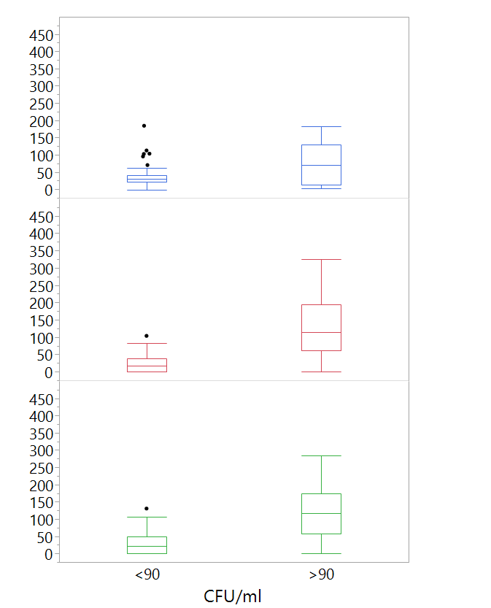

Predicted Bacterial Concentration [log10(CFU/ml)



Figure 19. Box plots of predicted heterotrophic bacteria concentrations using different ??? versus real heterotrophic bacteria counts in groundwater. Astrixes mark significant difference between groups according to a Wilcoxon test, p<0.01. n=57. Boxes illustrate median and interquartile range (IQR), whiskers indicate 25th and 75th percentile, outliers are shown.

**\***

**\***

Figure 19 illustrates the difference between using a PLS model for the emission spectrum upon excitation at 275 nm, PLS model for the entire EEM and single wavelength pair analysis (at 275 nm excitation and 362 nm emission). While the differences are not immediately apparent to the eye, statistical testing shows that by using a PLS model based on the full EEM or even the emission spectrum upon excitation at 275 nm, differentiation between samples with over or under 90 CFU/ml can be achieved.

Currently, based on this study, it is difficult to conclude which approach - the use of EEMs, single emission spectrum or single excitation/emission wavelength pair fluorescence measurements - will be best applied for detection of low concentrations of heterotrophic bacteria in drinking water. However, based on the experience with identification and quantification of pure culture bacteria, one may expect that use of the whole EEM data might be more efficient for successful detection of microbial contamination of water.

### Spectral fingerprints based on PLS model variable importance

In order to see what spectral regions of EEM are important for detecting microorganisms in water, variable importance (VI) was calculated for each excitation-emission wavelength pair.

For this analysis, the VI values were plotted from the PLS model based on the emission spectrum upon excitation at 275 nm (Figure 18). The upper wavelength limit in Figure 18 is 410 nm because the scans of groundwater samples were made up to this limit while the pathogen scans ended at 450 nm. The shaded regions illustrate that there are slight differences between different bacteria's spectral fingerprints even in a model based only on the emission spectrum of a single excitation wavelength.

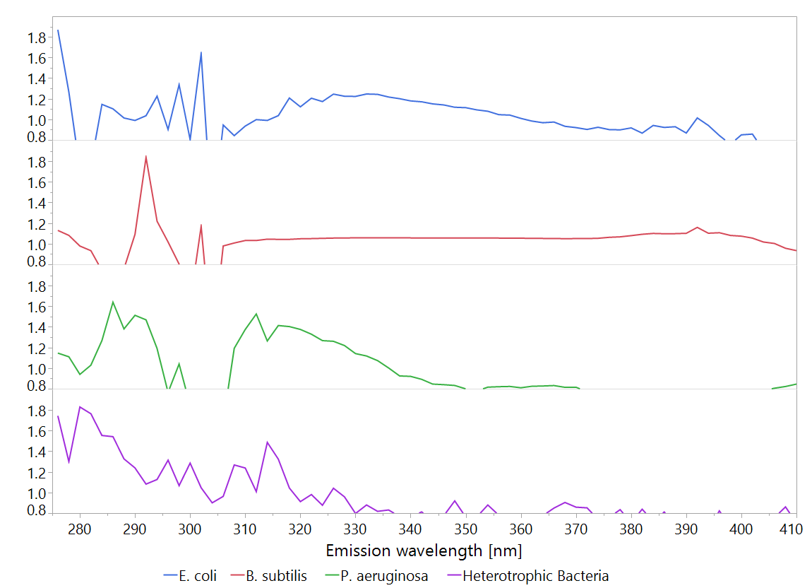

A

Figure 20. Variable importance (VI) plots of PLS models made from the emission spectrum upon excitation at 275 nm spectra. The plots show only values >0.8. Shades A-F indicate areas of significan signals which may be indicative bacterial concentration.

VI

B

C

D

E

When the VI values of entire EEM, characteristic for the excitation wavelength range of 210-400 nm and the emission wavelength of 220-450 nm were plotted (Figure 21), a difference between the spectral fingerprints could be observed. While most of the signal came from the proteinaceus fluorescence region (excitation wavelengths in the 220-230, 270-300 nm range, the emission in the 300-360 nm range, (Yang et al., 2015)), certain differences in this region between the different bacteria are visible. Furthermore, it appears that the scatter region (where the excitation and emission wavelengths do not differ more than by 10 nm) of the map is also of high importance to the model.

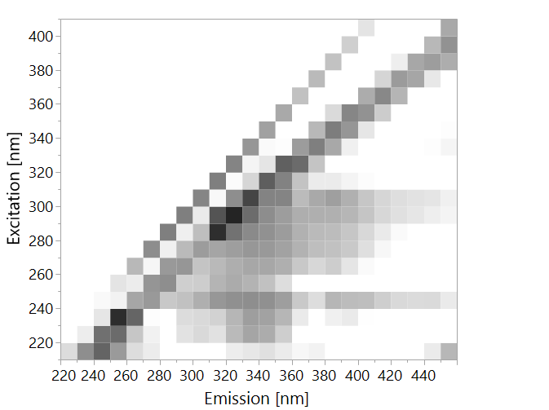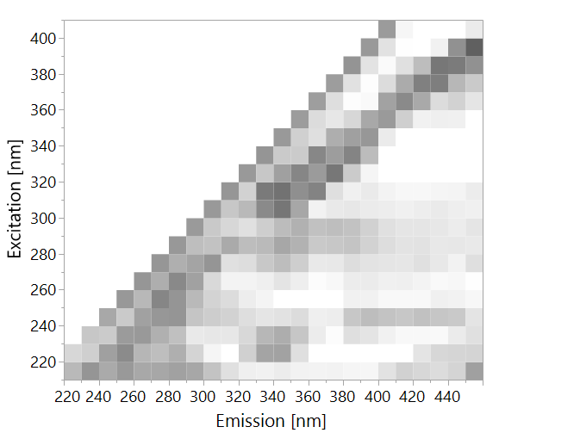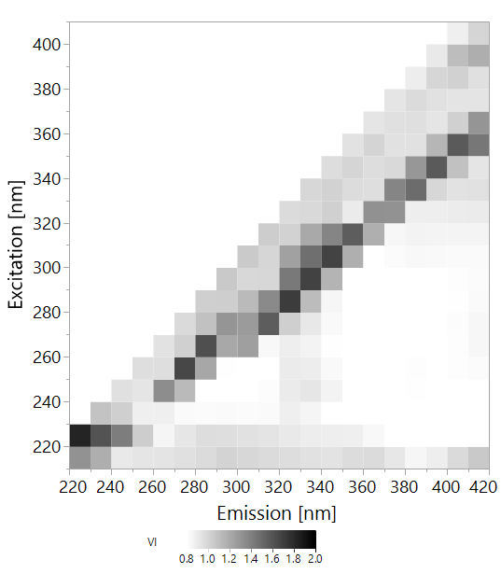

E. coli

Figure 21. Variable importance (VI) plots of PLS models made from entire EEMs. The plots show only values >0.8.

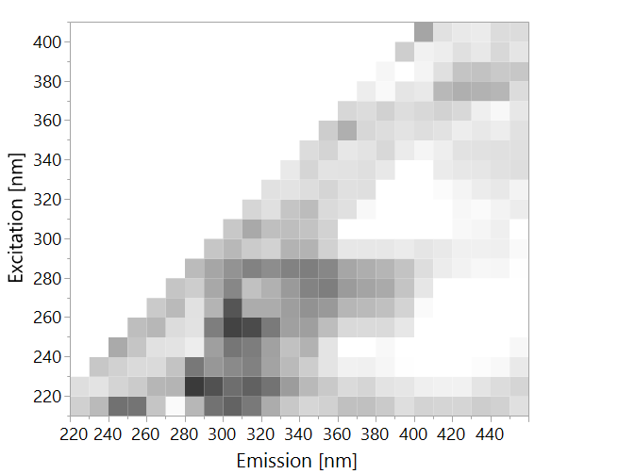

B. subtilis

P. aeruginosa

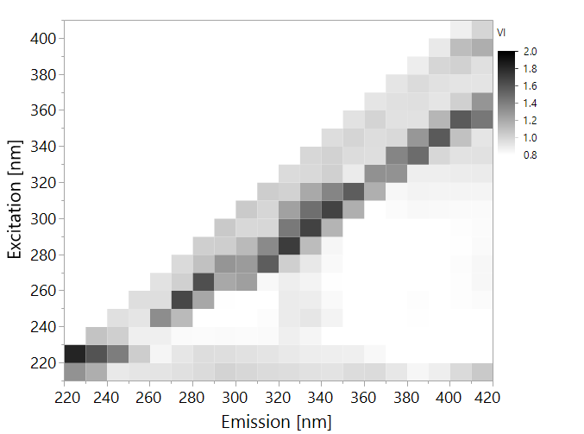

Heterotrophic Bacteria

It is surprising to see the importance of the Rayleigh scatter region and the Raman scatter region for the quantification of bacteria. It appears that all strains have some effect on light scattering, both Raman and Rayleigh, which was surprising since Raman spectrometry did not yield good results.

One explanation for this is that while the low resolution Raman spectrum was measured with excitation by near-infrared light (785 nm), the EEM were obtained using UV light (200-400 nm) which has much higher energy levels. It is difficult to explain currently how chemical composition present in different bacterial cells may be responsible for different fluorescence spectra of species. It is clear that proteinaceous substances demonstrating tryptophan-like fluorescence form a large part of the spectral fingerprint, but they may represent entire cells, live or dead, cell wall components or dissolved proteins and peptides which were excreted by the bacteria. Further studies are needed to elucidate the chemical and biological components leading to the observed fluorescence fingerprints. It is clear however that intensity of these fluorescence fingerprints correlates with the concentration of bacterial species.

### Differentiation between different species

In order to examine the ability of this approach to differentiate bacterial species present in water, samples were divided into 4 categories:

1. *E. coli* >104 CFU/ml
2. B. subtilis > 104 CFU/ml
3. P. aeruginosa > 104 CFU/ml
4. All samples at ≤1 CFU/ml – classified as "water"

A PLS-DA model wascalculated, in an attempt to classify these samples correctly, with the same training-validation ratio of 6:4. Table 9 illustrates the model's ability to accurately differentiate between different bacteria. *E. coli*, *B. subtilis* and *P. aeruginosa*, may indeed be differentiated however, the differentiation between *P. aeruginosa* and water is weak. This model has substantial agreement according to its Cohen's kappa coefficient of 0.78; which means it can correctly classify most of the samples.

Table 9. Confusion matrix of classification of microbes by PLS-DA, based on entire EEMs, at concentrations >104 CFU/ml. Only validation set is displayed. K=0.78

|  |  |  |  |  |  |  |  |
| --- | --- | --- | --- | --- | --- | --- | --- |
|  | Prediction | | | | | | |
| Actual |  | B. subtilis | E. coli | P. aeruginosa | Water | Total |
| B. subtilis | 8 | 0 | 0 | 0 | 8 |
| E. coli | 0 | 8 | 0 | 1 | 9 |
| P. aeruginosa | 0 | 0 | 5 | 7 | 12 |
| Water | 0 | 0 | 1 | 50 | 51 |
| Total | 8 | 8 | 6 | 58 | 80 |

It is not clear why *P. aeruginosa* was poorly distinguished. Nonetheless, the data analysis suggests that fluorescence spectroscopy of EEMs can be used to differentiate species of bacteria in pure, dense cultures.

# Conclusions

In conclusion, this study demonstrated a high potential of fluorescence spectroscopy for detecting microorganisms in water. This method can quickly and accurately detect bacterial presence in water, without the need for complex sample preparation or expensive reagents. It can also be applied for fast discrimination between different bacterial species in dense cultures, which has industrial and medical significance, such as quickly identifying a specific pathogen in a patient's urine and prescribing the suitable antibiotic (Pazos-Perez et al., 2016), or being able to tell if the wine-fermenting bacteria in a barrel are actually spoilers rather than the fermenters of aroma (Rodriguez et al., 2013).

That being said, further studies are needed to optimize the system for real drinking water in general, and in Israel particularly. Collection of a larger set of data, that will be more diverse and include more contamination events, could contribute to a more accurate, quick and efficient detection of bacteria in different types of water and specifically that one intended for drinking use.

# References

# תקציר

זיהום בקטריאלי של מי שתייה מהווה סכנה רבה לבריאות הציבור. מדי שנה, אלפי אנשים חולים במחלות הנישאות במים במדינות מפותחות, ומיליונים במדינות מתפתחות. בעוד רשויות המים מבצעות פעולות רבות כדי להבטיח את בטיחות מי השתייה, השיטות לבדיקות סניטציה של מים הן איטיות מדי, ולוקחות בין 12-72 שעות כדי לייצר תוצאות. שיטות מודרניות מולקולריות הוצעו כתחליפים לשיטות הסטנדרטיות, כולל הגברת רצפי דנ"א, Enzyme-Linked Immunosorbent Assay (ELISA) וספקטרומטריית מסות. על אף זאת, שיטות אלה אינן מתאימות לבדיקות בקנה מידה תעשייתי היות והן יקרות מדי או אינן מדויקות מספיק. גישות מבוססות ספקטרוסקופיית אור, כגון ראמאן וספקטרוסקופיית פלואורסנציה הן שיטות אנליטיות מודרניות ומהירות אשר ניתן להחיל על גילוי של חיידקים במי שתייה. שיטות אלה מבוססות על הארת דוגמה באמצעות מקור אור ומדידות ההשפעה של הדוגמה על האור הנפלט.

במחקר זה, ספקטרוסקופיית ראמאן ברזולוציה נמוכה וספקטרוסקופיית פלואורסנציה שימשו כדי לנסות לגלות חיידקים, תחילה במערכת מודל ולאחר מכן במי שתייה אמיתיים. חיידקי *E. coli,* B. subtilis ו-*P. aeruginosa* שימשו להערכת ספי הגילוי של השיטות השונות, על ידי מדידת ספקטרום האור באמצעות ספקטרומטר ראמאן או בעזרת ספקטרופלואורומטר. אנליזת Partial Least Squares (PLS) שימשה לניתוח הספקטרה המורכבים, כיוון שלא נמצאו שיאים (Peaks) מובהקים. לאחר מכן, נמדדו מי שתייה אמיתיים מבארות בצפון ישראל באמצעות ספקטרומטריית פלואורסנציה, על מנת לקבוע את היכולת של השיטה לזהות זיהום של מי שתייה אמיתיים.

נמצא כי ספקטרוסקופיית ראמאן ברזולוציה נמוכה אינה כלי בעל ערך רב עבור זיהוי של חיידקים במים, עם ספי גילוי של 108 ו-104 CFU/ml ​​עבור *E. coli* ו-*B. subtilis* בהתאמה. ספקטרוסקופיית פלואורסנציה לעומת זאת, הראתה פוטנציאל גדול לזיהוי וכימות של חיידקים במים, גילוי חיידקים בסף גילוי נמוך עד כדי 10 CFU/ml עבור מינים מסוימים. יתר על כן, מודל סיווג היה מסוגל להבדיל במדויק בין *E. coli*, *B. subtilis* ו-*P. aeruginosa* בריכוזים גבוהים, ממצא המצביע על טביעות אצבע ספקטרליות שונות בין המינים. במי השתייה האמיתיים נמצא כי במערך הנתונים יש מעט מאוד מקרים של זיהום, כאשר רק מדגם אחד מזוהם באופן רשמי לאורך כל תקופת הדגימה. במדגם זה ניתן, בכל זאת, להבחין בזיהום בקלות באמצעות ספקטרוסקופיית פלואורסנציה, וטיפול במים על ידי כלור או סינון הפחית את טביעת אצבע הספקטרלית כמעט לחלוטין, ממצא המציין את הקשר בין זיהום מיקרוביאלי ופלואורסנציה.

הן בניסויים מבוקרים במעבדה והן במי שתייה אמיתיים, ספקטרוסקופיית פלואורסנציה הראתה יכולת לגלות חיידקים בריכוז של 1,000 CFU/ml המהווה את הסטנדרט התעשייתי הנדרש. יתר על כן, המחקר ממחיש את בשיפור ברגישות אשר ניתן להשיג באמצעות ניתוח הספקטרום התלת-ממדי המורכב של ספקטרוסקופיית פלואורסנציה לעומת שימוש באורך גל יחיד "Peak Picking". בניסוי מבוקר, אלגוריתם PLS שחושב על מפת עירור-פליטה מלאה (Excitation Emission Map, EEM) בטווח של 210-400 ננומטר עירור ו-220-450 ננומטר פליטה הגדיל את הרגישות מ-105 CFU/ml עד 10 CFU/ml. שיטה זו גם מאפשרת הבחנה בין מינים שונים על פי טביעת האצבע הספקטרלית שלהם. מחקר זה ממחיש את הפוטנציאל הגבוה של ספקטרוסקופיה פלואורסנציה לזיהוי מהיר ומדויק של חיידקים במי השתייה.

. Kaiser Optical Systems -  Raman Spectroscopy - A Tutorial.

(2013). תקנות בריאות העם - איכותם התברואית של מי־שתיה ומיתקני מי שתיה.

(2016). הנחיות לדיגום מים.

(2017). הנחיות המנהל להגשת תכנית, לתפעול וניטור מתקן טיפול במי שתיה.

Allen, M.J., Edberg, S.C., and Reasoner, D.J. (2004). Heterotrophic plate count bacteria—what is their significance in drinking water? International Journal of Food Microbiology *92*, 265-274.

Ashbolt, N.J. (2015). Microbial Contamination of Drinking Water and Human Health from Community Water Systems. Curr Environ Health Rep *2*, 95-106.

Baghoth, S.A., Sharma, S.K., and Amy, G.L. (2011). Tracking natural organic matter (NOM) in a drinking water treatment plant using fluorescence excitation–emission matrices and PARAFAC. Water Research *45*, 797-809.

Baker, A., Cumberland, S.A., Bradley, C., Buckley, C., and Bridgeman, J. (2015). To what extent can portable fluorescence spectroscopy be used in the real-time assessment of microbial water quality? Science of The Total Environment *532*, 14-19.

Belal, T., Romdhane, K., Jean-Louis, B., Tahar, B., Eric, D., and Françoise, L. (2011). Optical fiber-based synchronous fluorescence spectroscopy for bacterial discrimination directly from colonies on agar plates. Analytical Methods *3*, 133-143.

Bernhard, S. (1995). Special techniques and applications. In Infrared and Raman Spectroscopy - Methods and Application, S. Bernhard, ed. (Weinheim, Federal Republic of Germany: VCH Verlagsgesellschaft).

Bernhard, S. (1995  ). General survey of vibrational spectroscopy. In Infrared and Raman Spectroscopy - Methods and Application, S. Bernhard, ed. (Weinheim, Federal Republic of Germany: VCH Verlagsgesellschaft).

Bieroza, M., Baker, A., and Bridgeman, J. (2009). Exploratory analysis of excitation-emission matrix fluorescence spectra with self-organizing maps as a basis for determination of organic matter removal efficiency at water treatment works. Journal of Geophysical Research-Biogeosciences *114*.

Borisover, M., Laor, Y., Parparov, A., Bukhanovsky, N., and Lado, M. (2009). Spatial and seasonal patterns of fluorescent organic matter in Lake Kinneret (Sea of Galilee) and its catchment basin. Water Research *43*, 3104-3116.

Boyaci, I.H., Temiz, H.T., Geniş, H.E., Acar Soykut, E., Yazgan, N.N., Güven, B., Uysal, R.S., Bozkurt, A.G., İlaslan, K., Torun, O.*, et al.* (2015). Dispersive and FT-Raman spectroscopic methods in food analysis. RSC Advances *5*, 56606-56624.

Bridgeman, J., Baker, A., Brown, D., and Boxall, J.B. (2015). Portable LED fluorescence instrumentation for the rapid assessment of potable water quality. Science of The Total Environment *524-525*, 338-346.

Cabral, J.P. (2010). Water microbiology. Bacterial pathogens and water. Int J Environ Res Public Health *7*, 3657-3703.

Carstea, E.M., Bridgeman, J., Baker, A., and Reynolds, D.M. (2016). Fluorescence spectroscopy for wastewater monitoring: A review. Water Research *95*, 205-219.

Cohen, E., Levy, G.J., and Borisover, M. (2014). Fluorescent components of organic matter in wastewater: efficacy and selectivity of the water treatment. Water Research *55*, 323-334.

Collier, S.A., Stockman, L.J., Hicks, L.A., Garrison, L.E., Zhou, F.J., and Beach, M.J. (2012). Direct healthcare costs of selected diseases primarily or partially transmitted by water. Epidemiol Infect *140*, 2003-2013.

Costa, D., Bousseau, A., Thevenot, S., Dufour, X., Laland, C., Burucoa, C., and Castel, O. (2015). Nosocomial outbreak of Pseudomonas aeruginosa associated with a drinking water fountain. J Hosp Infect *91*, 271-274.

Cumberland, S., Bridgeman, J., Baker, A., Sterling, M., and Ward, D. (2012). Fluorescence spectroscopy as a tool for determining microbial quality in potable water applications. Environmental Technology *33*, 687-693.

Determann, S., Lobbes, J.M., Reuter, R., and Rullkötter, J. (1998). Ultraviolet fluorescence excitation and emission spectroscopy of marine algae and bacteria. Marine Chemistry *62*, 137-156.

Duanis-Assaf, D., Duanis-Assaf, T., Zeng, G., Meyer, R.L., Reches, M., Steinberg, D., and Shemesh, M. (2018). Cell wall associated protein TasA provides an initial binding component to extracellular polysaccharides in dual-species biofilm. Sci Rep *8*, 9350.

Eaton, A., Clesceri, L.S., Rice, E.W., Greenberg, A.E., and Franson, M. (2005). APHA: standard methods for the examination of water and wastewater. Centennial Edition, APHA, AWWA, WEF, Washington, DC.

Eberhardt, K., Stiebing C Fau - Matthaus, C., Matthaus C Fau - Schmitt, M., Schmitt M Fau - Popp, J., and Popp, J. Advantages and limitations of Raman spectroscopy for molecular diagnostics: an update.

Edberg, S.C., Rice, E.W., Karlin, R.J., and Allen, M.J. (2000). Escherichia coli: the best biological drinking water indicator for public health protection. Symp Ser Soc Appl Microbiol, 106S-116S.

Elliott, S., Lead, J.R., and Baker, A. (2006). Characterisation of the fluorescence from freshwater, planktonic bacteria. Water Research *40*, 2075-2083.

Eriksson, L., Andersson, P.L., Johansson, E., and Tysklind, M. (2006). Megavariate analysis of environmental QSAR data. Part I – A basic framework founded on principal component analysis (PCA), partial least squares (PLS), and statistical molecular design (SMD). Molecular Diversity *10*, 169-186.

Fearn, T. (2002). Assessing Calibrations: SEP, RPD, RER and R2. NIR news *13*, 12-13.

Fehrmann, A., Franz, M., Hoffmann, A., Rudzik, L., and Wüst, E. (1995). Dairy product analysis: identification of microorganisms by mid-infrared spectroscopy and determination of constituents by Raman spectroscopy. J AOAC Int *78*, 1537-1542.

Frolich, L., Vaizel-Ohayon, D., and Fishbain, B. (2017). Prediction of Bacterial Contamination Outbursts in Water Wells through Sparse Coding. Scientific Reports *7*, 799.

Geladi, P., and Kowalski, B.R. (1986). Partial least-squares regression: a tutorial. Analytica Chimica Acta *185*, 1-17.

George, S. (2001). Infrared and Raman Characteristic Group Frequencies (Chichester, England: John Wiley & sons Ltd.).

Gholizadeh, A., Boruvka, L., Saberioon, M., Kozák, J., Vašát, R., and Němeček, K. (2015). Comparing Different Data Preprocessing Methods for Monitoring Soil Heavy Metals Based on Soil Spectral Features.

Heibati, M., Stedmon, C.A., Stenroth, K., Rauch, S., Toljander, J., Säve-Söderbergh, M., and Murphy, K.R. (2017). Assessment of drinking water quality at the tap using fluorescence spectroscopy. Water Research *125*, 1-10.

Hennekinne, J.A., De Buyser, M.L., and Dragacci, S. (2012). Staphylococcus aureus and its food poisoning toxins: characterization and outbreak investigation. FEMS Microbiol Rev *36*, 815-836.

Information, N.C.f.B. (2018). Tyrosine CID=6057, Phenylalanine CID=6305, Tryptophan CID=6140 (PubChem Compound Database).

Ishii, S.K.L., and Boyer, T.H. (2012). Behavior of Reoccurring PARAFAC Components in Fluorescent Dissolved Organic Matter in Natural and Engineered Systems: A Critical Review. Environmental Science & Technology *46*, 2006-2017.

Jarvis, R.M., Brooker, A., and Goodacre, R. (2006). Surface-enhanced Raman scattering for the rapid discrimination of bacteria. Faraday Discuss *132*, 281-292; discussion 309-219.

Jean, N.B., C, and Simorre, J.P. (2018). The Structure of Bacterial Cell Wall.

Krafft, C., and Popp, J. The many facets of Raman spectroscopy for biomedical analysis.

Kriegsmann, J., Casadonte, R., Kriegsmann, K., Longuespée, R., and Kriegsmann, M. (2018). Mass spectrometry in pathology – Vision for a future workflow. Pathology - Research and Practice.

L, Z., and S, E. (2005). Surface-enhanced Raman spectroscopy of bacteria: the effect of excitation wavelength and chemical modification of the colloidal milieu. Journal of Raman Spectroscopy *36*, 667-675.

Lakowicz, J.R. (2006). **Introduction to Fluorescence**. In *Principles of Fluorescence Spectroscopy*, J.R. Lakowicz, ed. (Maryland, USA: Springer).

Landis, J.R., and Koch, G.G. (1977). The Measurement of Observer Agreement for Categorical Data. Biometrics *33*, 159-174.

Leclerc, H., Schwartzbrod, L., and Dei-Cas, E. (2002). Microbial Agents Associated with Waterborne Diseases. Critical Reviews in Microbiology *28*, 371-409.

Li, Y.-S., and Church, J.S. (2014). Raman spectroscopy in the analysis of food and pharmaceutical nanomaterials. Journal of Food and Drug Analysis *22*, 29-48.

Madigan, M.T., Martinko, J.M., and Brock, T.D. (2006). Brock biology of microorganisms, 11th edn (Upper Saddle River, N.J.: Pearson/Prentice Hall).

Manoharan, R., Ghiamati, E., Dalterio, R.A., Britton, K.A., Nelson, W.H., and Sperry, J.F. (1990). UV resonance Raman spectra of bacteria, bacterial spores, protoplasts and calcium dipicolinate. Journal of Microbiological Methods *11*, 1-15.

Maquelin, K., Choo-Smith, L.P., van Vreeswijk, T., Endtz, H.P., Smith, B., Bennett, R., Bruining, H.A., and Puppels, G.J. (2000). Raman spectroscopic method for identification of clinically relevant microorganisms growing on solid culture medium. Anal Chem *72*, 12-19.

Meisel, S., Stöckel, S., Elschner, M., Melzer, F., Rösch, P., and Popp, J. (2012). Raman spectroscopy as a potential tool for detection of Brucella spp. in milk. Appl Environ Microbiol *78*, 5575-5583.

Meisel, S., Stöckel, S., Rösch, P., and Popp, J. (2014). Identification of meat-associated pathogens via Raman microspectroscopy. Food Microbiol *38*, 36-43.

Mello, C., Ribeiro, D., Novaes, F., and Poppi, R.J. (2005). Rapid differentiation among bacteria that cause gastroenteritis by use of low-resolution Raman spectroscopy and PLS discriminant analysis. Anal Bioanal Chem *383*, 701-706.

Mizrach, A., Schmilovitch, Z.e., Korotic, R., Irudayaraj, J., and Shapira, R. (2007). Yeast Detection in Apple Juice Using Raman Spectroscopy and Chemometric Methods.

Naumann, D., Keller, S., Helm, D., Schultz, C., and Schrader, B. (1995). FT-IR spectroscopy and FT-Raman spectroscopy are powerful analytical tools for the non-invasive characterization of intact microbial cells. Journal of Molecular Structure *347*, 399-405.

Nebbioso, A., and Piccolo, A. Molecular characterization of dissolved organic matter (DOM): a critical review.

Nicolaou, N., Xu, Y., and Goodacre, R. (2011). Fourier transform infrared and Raman spectroscopies for the rapid detection, enumeration, and growth interaction of the bacteria Staphylococcus aureus and Lactococcus lactis ssp. cremoris in milk. Anal Chem *83*, 5681-5687.

Pahlow, S., Meisel, S., Cialla-May, D., Weber, K., Rösch, P., and Popp, J. (2015). Isolation and identification of bacteria by means of Raman spectroscopy. Adv Drug Deliv Rev *89*, 105-120.

Pazos-Perez, N., Pazos, E., Catala, C., Mir-Simon, B., Gómez-de Pedro, S., Sagales, J., Villanueva, C., Vila, J., Soriano, A., García de Abajo, F.J.*, et al.* (2016). Ultrasensitive multiplex optical quantification of bacteria in large samples of biofluids. Sci Rep *6*, 29014.

Premasiri, W.R., Chen, Y., Williamson, P.M., Bandarage, D.C., Pyles, C., and Ziegler, L.D. (2017). Rapid urinary tract infection diagnostics by surface-enhanced Raman spectroscopy (SERS): identification and antibiotic susceptibilities. Anal Bioanal Chem *409*, 3043-3054.

Premasiri, W.R., Moir, D.T., Klempner, M.S., Krieger, N., Jones, G., and Ziegler, L.D. (2005). Characterization of the Surface Enhanced Raman Scattering (SERS) of Bacteria. The Journal of Physical Chemistry B *109*, 312-320.

R., L.J. (2006). Protein Fluorescnce. In Principles of  Fluorescence Spectroscopy (Singapore: Springer), pp. 529-570

Rodriguez, S.B., Thornton, M.A., and Thornton, R.J. (2013). Raman Spectroscopy and Chemometrics for Identification and Strain Discrimination of the Wine Spoilage Yeasts Saccharomyces cerevisiae, Zygosaccharomyces bailii, and Brettanomyces bruxellensis. Applied and Environmental Microbiology *79*, 6264-6270.

Rompré, A., Servais, P., Baudart, J., de-Roubin, M.-R., and Laurent, P. (2002). Detection and enumeration of coliforms in drinking water: current methods and emerging approaches. Journal of Microbiological Methods *49*, 31-54.

Rösch, P., Harz, M., Schmitt, M., Peschke, K.D., Ronneberger, O., Burkhardt, H., Motzkus, H.W., Lankers, M., Hofer, S., Thiele, H.*, et al.* (2005). Chemotaxonomic identification of single bacteria by micro-Raman spectroscopy: application to clean-room-relevant biological contaminations. Appl Environ Microbiol *71*, 1626-1637.

Schmilovitch, Z., Mizrach, A., Alchanatis, V., Kritzman, G., Korotic, R., Irudayaraj, J., and Debroy, C. (2005). DETECTION OF BACTERIA WITH LOW-RESOLUTION  RAMAN SPECTROSCOPY  Transactions of the American Society of Agricultural Engineers *48*, 1843-1850.

Simelane, K.S. (2013). Application of Fluorescence Spectroscopy for Monitoring Microbial Contamination of Drinking Water. In <div ng-repeat="value in detailvalues" style="box-sizing: border-box;"><div aria-hidden="false" class="word-break layout-column" layout="column" ng-repeat="curValue in $ctrlgetValuesOfValueItems(value) track by $index" ng-show="$first || !detailisCollapsible || !detailshowMore" style="box-sizing: border-box; display: flex; flex-direction: column; word-wrap: break-word;"><div aria-hidden="false" class="" ng-show="!valueisLinkable" style="box-sizing: border-box;"><prm-highlight ng-if="!$ctrlisSuprima()" style="box-sizing: border-box;" terms="$ctrlhl(valuekeyt)" text="curValue">Faculty of Agriculture, Food and Environment</prm-highlight> (Hebrew University of Jerusalem).

Socrates, G. (2001). Infrared and Raman Characteristic Group Frequencies (Chichester, England: John Wiley & sons Ltd.).

Sorensen, J.P.R., Baker, A., Cumberland, S.A., Lapworth, D.J., MacDonald, A.M., Pedley, S., Taylor, R.G., and Ward, J.S.T. (2018a). Real-time detection of faecally contaminated drinking water with tryptophan-like fluorescence: defining threshold values. Science of The Total Environment *622-623*, 1250-1257.

Sorensen, J.P.R., Lapworth, D.J., Marchant, B.P., Nkhuwa, D.C.W., Pedley, S., Stuart, M.E., Bell, R.A., Chirwa, M., Kabika, J., Liemisa, M.*, et al.* (2015). In-situ tryptophan-like fluorescence: A real-time indicator of faecal contamination in drinking water supplies. Water Research *81*, 38-46.

Sorensen, J.P.R., Vivanco, A., Ascott, M.J., Gooddy, D.C., Lapworth, D.J., Read, D.S., Rushworth, C.M., Bucknall, J., Herbert, K., Karapanos, I.*, et al.* (2018b). Online fluorescence spectroscopy for the real-time evaluation of the microbial quality of drinking water. Water Research *137*, 301-309.

Stedmon, C.A., Thomas, D.N., Granskog, M., Kaartokallio, H., Papadimitriou, S., and Kuosa, H. (2007). Characteristics of Dissolved Organic Matter in Baltic Coastal Sea Ice:  Allochthonous or Autochthonous Origins? Environmental Science & Technology *41*, 7273-7279.

Stöckel, S., Kirchhoff, J., Neugebauer, U., Röscha, P., and Popp, J. (2015). The application of Raman spectroscopy for the  detection and identification of microorganisms  Journal of Raman Spectroscopy, 89-109.

Stöckel, S., Schumacher, W., Meisel, S., Elschner, M., Rösch, P., and Popp, J. (2010). Raman spectroscopy-compatible inactivation method for pathogenic endospores. Appl Environ Microbiol *76*, 2895-2907.

Sundaram, J., Park, B., Hinton, A., Lawrence, K.C., and Kwon, Y. (2013a). Detection and differentiation of Salmonella serotypes using surface enhanced Raman scattering (SERS) technique. Journal of Food Measurement and Characterization *7*, 1-12.

Sundaram, J., Park, B., Kwon, Y., and Lawrence, K.C. (2013b). Surface enhanced Raman scattering (SERS) with biopolymer encapsulated silver nanosubstrates for rapid detection of foodborne pathogens. Int J Food Microbiol *167*, 67-73.

Tedetti, M., Joffre, P., and Goutx, M. (2013). Development of a field-portable fluorometer based on deep ultraviolet LEDs for the detection of phenanthrene- and tryptophan-like compounds in natural waters. Sensors and Actuators B: Chemical *182*, 416-423.

Walsh, J.D., Hyman, J.M., Borzhemskaya, L., Bowen, A., McKellar, C., Ullery, M., Mathias, E., Ronsick, C., Link, J., Wilson, M.*, et al.* (2013). Rapid intrinsic fluorescence method for direct identification of pathogens in blood cultures. MBio *4*, e00865-00813.

Wang, J., Xie, X., Feng, J., Chen, J.C., Du, X.J., Luo, J., Lu, X., and Wang, S. (2015). Rapid detection of Listeria monocytogenes in milk using confocal micro-Raman spectroscopy and chemometric analysis. Int J Food Microbiol *204*, 66-74.

Willemse-Erix, D.F., Scholtes-Timmerman, M.J., Jachtenberg, J.W., van Leeuwen, W.B., Horst-Kreft, D., Bakker Schut, T.C., Deurenberg, R.H., Puppels, G.J., van Belkum, A., Vos, M.C.*, et al.* (2009). Optical fingerprinting in bacterial epidemiology: Raman spectroscopy as a real-time typing method. J Clin Microbiol *47*, 652-659.

Williams, A.C., and Edwards, H.G.M. (1994). Fourier transform Raman spectroscopy of bacterial cell walls. Journal of Raman Spectroscopy *25*, 673-677.

Williams, P., and Norris, K.H. (2001). Near-infrared technology in the agricultural and food industries / ed. by Phil Williams, Karl Norris.

Yamashita, Y., Panton, A., Mahaffey, C., and Jaffé, R. (2011). Assessing the spatial and temporal variability of dissolved organic matter in Liverpool Bay using excitation–emission matrix fluorescence and parallel factor analysis. Ocean Dynamics *61*, 569-579.

Yang, L., Hur, J., and Zhuang, W. (2015). Occurrence and behaviors of fluorescence EEM-PARAFAC components in drinking water and wastewater treatment systems and their applications: a review. Environmental Science and Pollution Research *22*, 6500-6510.

Zeiri, L., Bronk, B.V., Shabtai, Y., Eichler, J., and Efrima, S. (2004). Surface-enhanced Raman spectroscopy as a tool for probing specific biochemical components in bacteria. Appl Spectrosc *58*, 33-40.

Zeiri, L., and Efrima, S. (2010). Surface-Enhanced Raman Scattering (SERS) of Microorganisms. Israel Journal of Chemistry *46*, 337-346.

Zhou, H., Yang, D., Ivleva, N.P., Mircescu, N.E., Niessner, R., and Haisch, C. (2014). SERS detection of bacteria in water by in situ coating with Ag nanoparticles. Anal Chem *86*, 1525-1533.